# What is Cloud Computing?

The practice of using a network of remote severs hosted on the Internet to store, manage, and process data, rather than a local server or personal computer.

**On-Premise**

* + You own the servers
  + You hire the IT people
  + You pay or rent the real-estate
  + You take all the risk

**Cloud Providers**

* + Someone else owns the servers
  + Someone else hires the IT people
  + Someone else pays or rents the real-estate
  + You are responsible for your configuring cloud services and code, someone else takes care of the next

# The Evolution of Cloud Hosting

1. **Dedicated Server**: One physical machine dedicated to a single business. Runs a single web-app/site. **Very** **expensive, high maintenance, high security.**

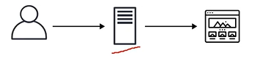

1. **Virtual Private Server (VPS):** One physical machine dedicated to a single business. The physical machine is virtualized into sub-machines. Runs multiple web-apps/sites. **Better utilization and isolation of resources.**

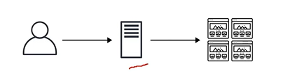

1. **Shared Hosting:** One physical machine, shared by hundreds of businesses. Relies on most tenants under-utilizing their resources**. Very cheap, limited functionality, poor isolation.**

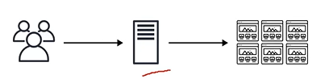

1. **Cloud Hosting:** Multiple physical machines that act as one system. The system is abstracted into multiple cloud services. **Flexible, Scalable, secure, cost-effective, high configuration.**

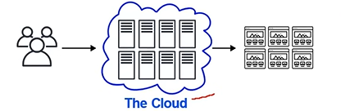

# Common Cloud Services

* A cloud provider can have hundreds of cloud services that are grouped various types of services. The four most common types of cloud services for infrastructure as a Service (IaaS) would be:
  + **Compute**: Imagine having a virtual computer that can run applications, programs and codes.
  + **Storage**: Imagine having a virtual hard-drive that can store files
  + **Networking**: Imagine having a virtual network being able to define internet connections or network isolations.
  + **Database**: Imagine a virtual database for storing, reporting data or a database for general purpose web-app.

# What is Microsoft?

* An American multinational computer technology corporation headquartered in Redmond, Washington.
* Microsoft makes softwares, phones, tablets, game consoles, cloud services, a search engine and more!
* Best known for Windows OS.

# What is Azure?

* Microsoft calls their cloud provider service Microsoft Azure or commonly referred to just Azure.



* Azure literally means “bright blue color of the cloudless sky”.

# Benefits of Cloud Computing

* **Cost-effective**: You pay for what you consume, no up-front cost. **Pay-as-you-go (PAYG)** thousands of customers sharing the cost of the resources.
* **Global**: Launch workloads **anywhere in the world.**
* **Secure**: Cloud provider takes care of physical security. Cloud services can be secure by default or you have the ability to configure access down to granular level.
* **Reliable**: Data backup, disaster recovery, and data replication, and fault tolerance
* **Scalable**: increase or decrease resources and services based on demand
* **Elastic**: **Automate** scaling during spikes and drop in demand.
* **Current**: The underlying hardware and managed software is patched, upgraded and replaced by the cloud provider without interruption to you.

# Types of Cloud Computing

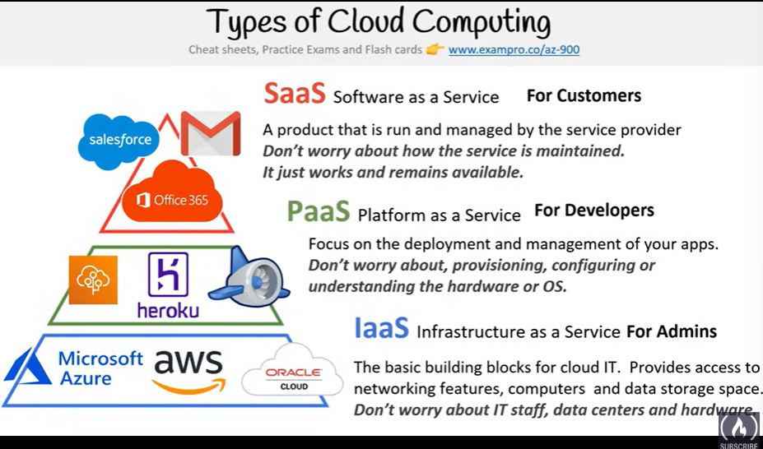

# Types of Cloud Computing Responsibilities

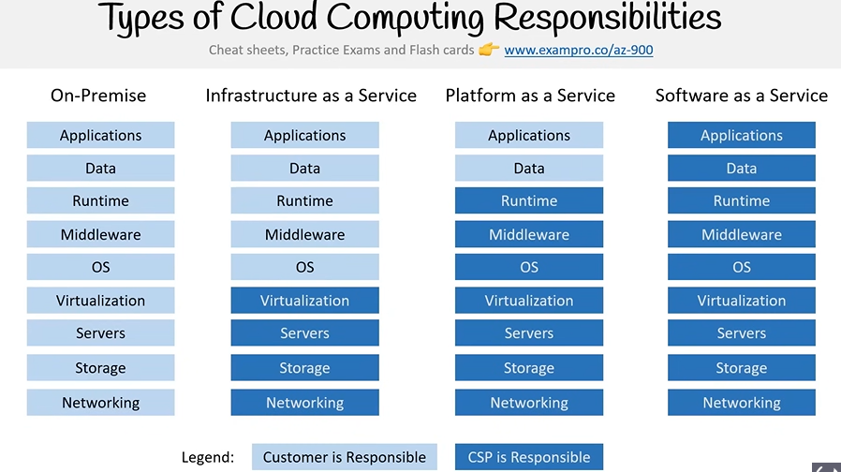

# Cloud Deployment Model

* **Public Cloud**: Everything built on the Cloud Provider. Also known as: Cloud-Native. You are not using anything on-premise or datacenters, everything is on Azure.

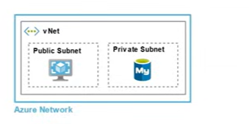

* **Private Cloud**: Everything built on company’s datacenters. Also known as On-Premise. This cloud could be OpenStack. In a private cloud, you create a cloud environment in your own datacenter and provide self-service access to compute resources to users in your organization. This offers a simulation of a public cloud to your users, but you remain completely responsible for the purchase and maintenance of the hardware and software services you provide.
* Finally, a private cloud may be hosted from your on-site datacenter. It may also be hosted in a dedicated datacenter offsite, potentially even by a third party that has dedicated that datacenter to your company.
* In a public cloud, services are offered over the internet and are available to anyone who wants to purchase them. A private cloud is limited to a single organization. Cloud resources, such as servers and storage, are owned and operated by a third-party cloud service provider and delivered over the internet. A private cloud consists of computing resources used exclusively by users from one business or organization.

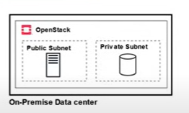

* **Hybrid**: Using both On-premise and a cloud service provider.

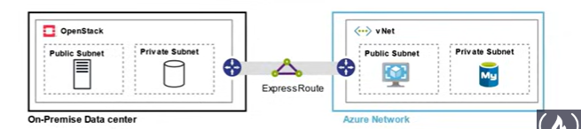

# Azure’s Deployment Models

* **Public Cloud**
  + Everything is built on the Cloud Provider
  + Also known as Cloud-Native

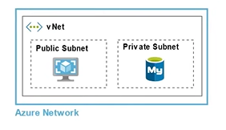

* **Private Cloud**
  + Everything built on company’s datacenters
  + Also known as On-Premise
  + The cloud could be OpenStack

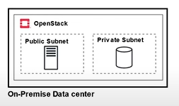

* **Hybrid**
  + Users both On-Premise and a cloud service provider
  + And they are connected together and there are lot of

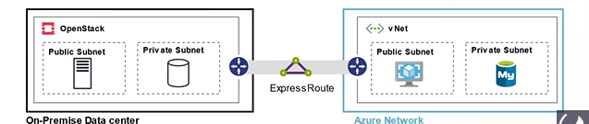

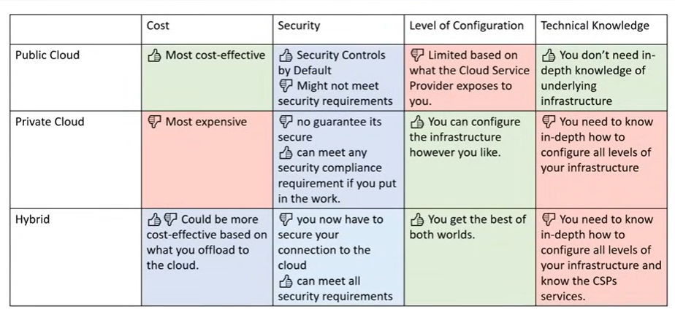

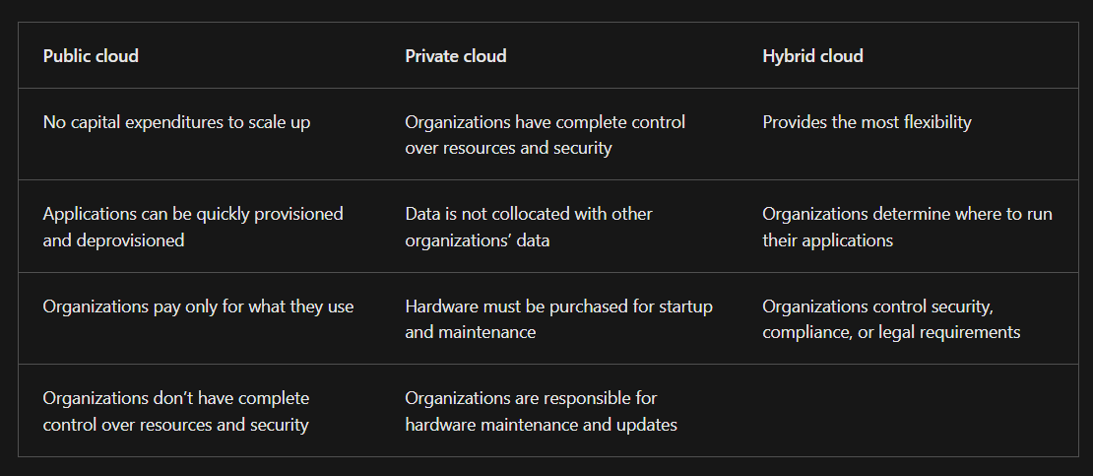

* **Cross-Cloud**
  + Using multiple cloud providers aka multi-cloud, hybrid-cloud

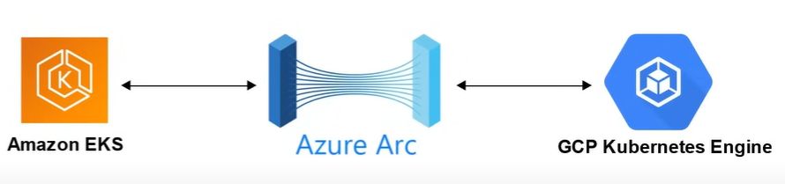

# Total Cost of Ownership

* Here in the below screenshot, we can see that, the On-Premise has more cost of ownership as we need to consider cost for implementation, configuration, training, physical security, hardware, IT personal and maintenance.
* Whereas when we use Azure, we need to take care of implementation, configuration and training while all the others cost elements are taken care by Azure.

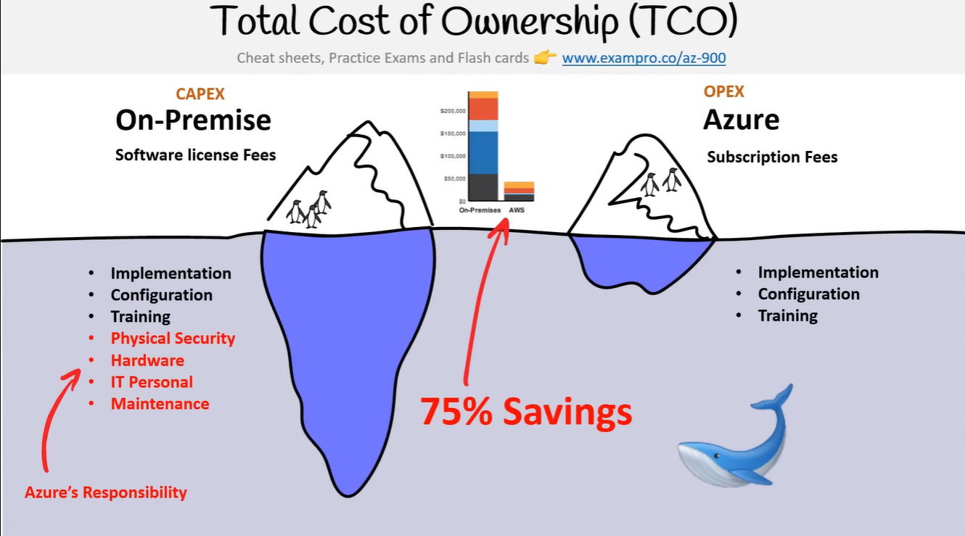

# Capital vs Operational Expenditure

* CAPEX (Capital Expenditure)
  + It means that spending money upfront on physical infrastructure. Deducting this expense from your tax bill over time.
  + Some of the things would be considered as capex are:

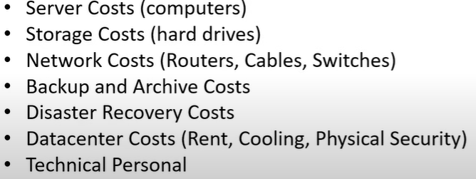

* + With capex we have to guess upfront what we plan to spend.
* OPEX (Operational Expenditure)
  + The costs associated with on-premises datacenters that has shifted the cost to the service provider. The customer only has to be concerned with non-physical costs.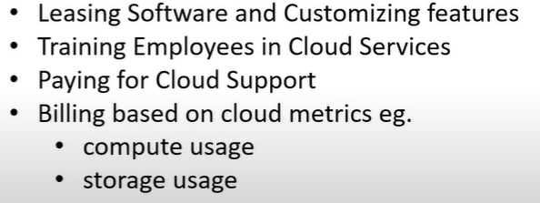
  + With opex we can try a product for service without investing in equipment.

# Cloud Architecture Terminologies

* What is solution architect?
  + A role in a technical organization that architects a technical solution using multiple systems via researching, documentation, experimentation
  + A solution architect also needs to consider how secure and how cost efficient the solution is.
* Cloud Architect?
  + A solutions architect that is focused solely on architecting technical solutions using cloud services
  + A cloud architect needs to understand the following terms and factor them into their designed architecture based on the business requirements:
    - **Availability**: your ability to ensure a service remains available e.g. High Availability
    - **Scalability**: your ability to grow rapidly or unimpeded
    - **Elasticity**: your ability to grow and shrink to need the demand
    - **Fault Tolerance**: your ability to prevent failure
    - **Disaster Recovery**: your ability to recover from failure e.g. Highly Durable

## High Availability

* Your ability for your service to remain available by ensuring there is no single point of failure and/or ensure a certain level of performance
* Running your workloads across multiple Availability Zones ensures that if 1 or 2 AZs become unavailable your services / applications remain available.

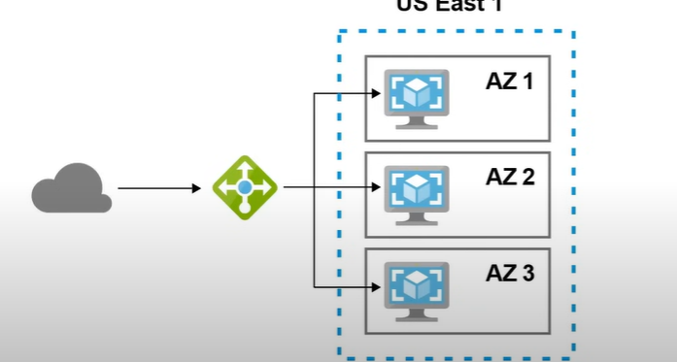

### Azure Load Balancer

* A load balancer allows you to evenly distribute the traffic to multiple servers in one or datacenter.
* If a datacenter or server becomes unavailable the load balancer will route the traffic to only available datacenters with servers.

## High Scalability

* Your ability to increase the capacity based on the increasing demand of traffic, memory and computing power.
* **Vertical Scaling** **–** This is also known as scaling up. This means upgrade to a bigger server.
* **Horizontal Scaling –** This is also known as scaling out. This means we add more servers of the same size.

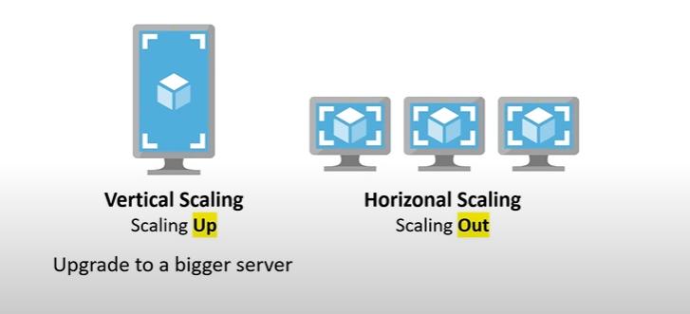

## High Elasticity

* The ability to automatically increase or decrease your capacity based on the current demand of traffic, memory and computing power.
* Here we use **Horizontal scaling** which means we either use **scaling** **out** i.e. add more servers of the same size or use **scaling** **in** i.e. removing more servers of the same size.
* Vertical scaling is hard for elasticity.
* **Azure VM Scale Sets** – Automatically increase or decrease in response to demand or a defined schedule.
* **SQL Server Stretch Database** – Dynamically stretch warm and cold transactional data from Microsoft SQL Server 2016 to Microsoft Azure.

## Fault Tolerance

* The ability for service to ensure there is no single point of failure. Preventing the chance of failure.
* **Fail-overs** is when you have a plan to shift traffic to a redundant system in case the primary system fails.

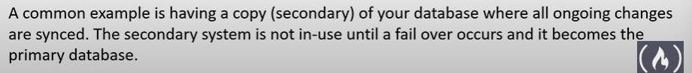

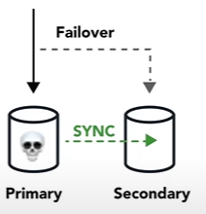

* You can use **Azure Traffic Manager** which is a DNS-based traffic balancer to fail-over from a failing primary system to a stand-by secondary system.

## High Durability

* The ability to recover from a disaster and to prevent the loss of data. Solutions that recover from a disaster is known as **Disaster Recover (DR).**

## Predictibility

* Predictability in the cloud refers to the ability to anticipate service performance and costs. Azure provides this through:
  + Service Level Agreements (SLAs): Microsoft Azure offers comprehensive SLAs that guarantee certain uptime percentages and sets expectations for service availability.
  + Transparent Costs: With Azure’s pricing calculator and cost management tools, businesses can forecast and manage their spending on the cloud.
  + Performance Standards: Azure services come with expected performance metrics. This helps organizations plan around these baselines to ensure they meet their performance benchmarks.

# Business Continuity Plan (BCP)

* A BCP is a document that outlines how a business will continue operating during an unplanned disruption in services.
* **Recovery Point Objectives (RPO)**
  + The maximum acceptable amount of data loss after an unplanned data-loss incident, expresses as an amount of time
* **Recovery Time Objective (RTO)**
  + The maximum amount of downtime your business can tolerate without incurring a significant financial loss.

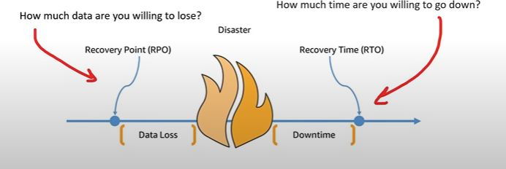

## Disaster Recovery Options

There are multiple options for recovery that trade cost vs time to recover.

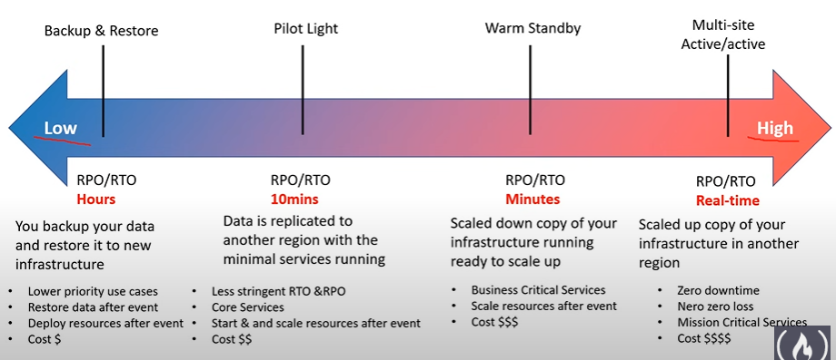

* Disaster recovery uses services, such as cloud-based backup, data replication, and geo-distribution, to keep data and code safe in the event of a disaster.

# Evolution of Computing

## Dedicated Server

* A physical server wholly utilized by a single customer.
* You have to guess your capacity, you will overpay for an underutilized server
* Upgrading beyond your capacity will be slow and expensive
* You are limited by your operating system
* Multiple apps can result in conflicts in resource sharing
* You have a guarantee of security, privacy and full utility of underlying resources.

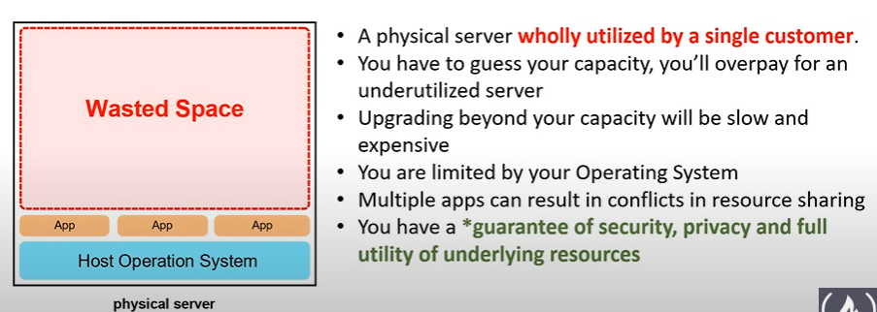

## Virtual Machine

* You can run multiple virtual machines on one machine.
* The technology that is used to run VMs is called Hypervisor. Hypervisor is the s/w layer that lets you use the VM.
* A physical server shared by multiple customers.
* You are pay for a fraction of the server.
* You will overpay for an underutilized VM.
* You are limited by your Guest OS.
* Multiple apps on a single VM can result in conflicts in resource sharing.

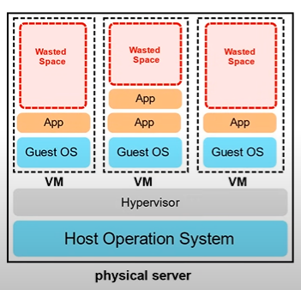

## Container

* VM running multiple containers.
* Docker Deamon is the name of the s/w layer that lets you run multiple containers.
* You can maximize the utilize the available capacity which is more cost-effective.
* Your containers share the same underlying OS so containers are more efficient than multiple VMs
* Multiple apps can run side by side without being limited to the same OS requirements and will not cause conflicts during resource sharing.

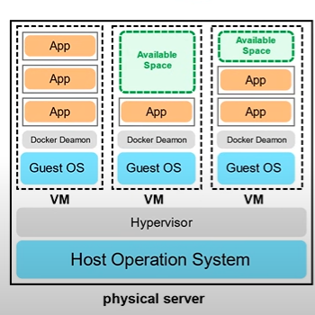

## Functions

* Here we subdivide even further. We have taken our applications that we run in containers where we break up the app into little pieces of code called functions.
* A managed VMs running managed containers.
* It is Platform as a Service.
* Known as **Serverless Computing**.
* You upload a piece of code choose the amount of memory and duration.
* Only responsible for code and data, nothing else.
* Very cost effective, only pay for the time code is running, VMs only run when there is code to be executed.
* Cold Starts is a side effect of this setup because servers are not running if there is no code to run, then when we execute the code, we have to wait for the server to start and eventually run the code.

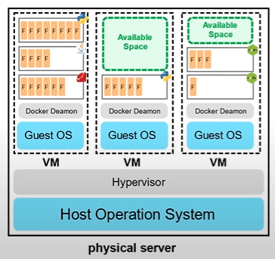

# Global Infrastructure

## Regions and Geographies

* A region is a grouping of multiple datacenters (Availability Zones).
* Azure has 58 regions available across 140 countries.
* A geography is discreet market of two or more regions that preserves data residency and compliance boundaries.
* Different locations can have different associated prices.

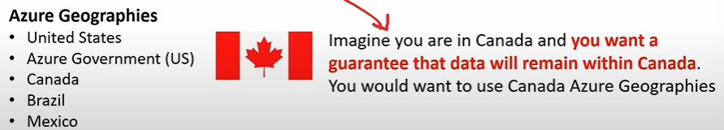

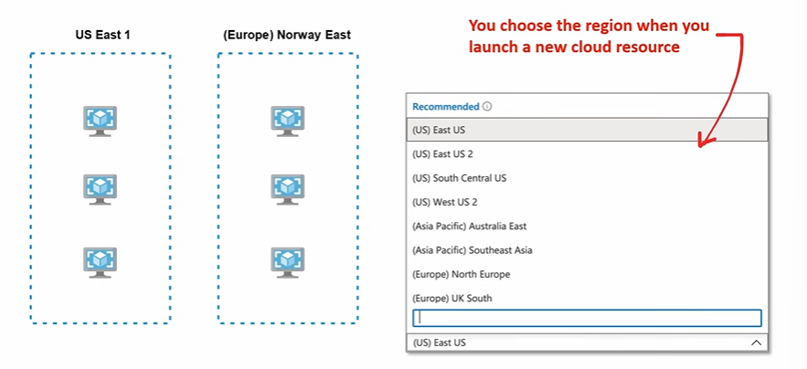

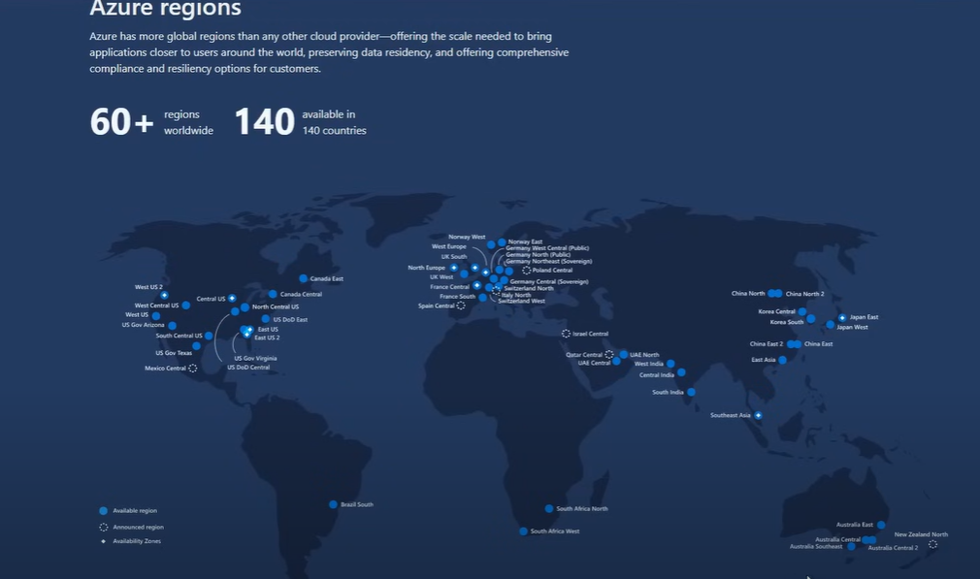

## Paired Regions

* Each region is paired with another region 300 miles away.
* Only one region is updated at a time to ensure no outages.
* Some Azure Services rely on paired regions for Disaster Recovery.
* **Azure Geo-redundant Storage (AGS)** replicated data to a secondary region automatically, ensuring that data is durable even in the event that the primary region isn’t recoverable.

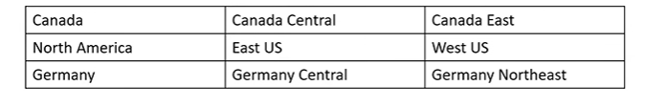

## Region Types and Service Availability

* **Not all Azure cloud services** are available in every Region.
* **Recommended region** - A region that provides the broadest range of service capabilities and is designed to support Availability Zones now, or in the future.
* **Alternate (other) region** - A region that extends Azure’s footprint within a data residency boundary where a recommended region also exists. Not designed to support AZs. These Regions are labeled as **Other** in Azure Portal.
* **General availability (GA)** is when a service is considered ready to be used publicly by everyone.
* Azure cloud services are grouped into **three** categories. Their category determines when cloud services become available:
  + **Foundational –** When GA, immediately or in 12 months in Recommended and Alternate Regions
  + **Mainstream –** When GA immediately or in 12 months in Recommended Regions but may become available in Alternate Regions based on customer demand.
  + **Specialized –** Available in Recommended or Alternate Region based on customer demand.

## Special Regions

* Azure has specialized regions to meet **compliance or legal reasons.**

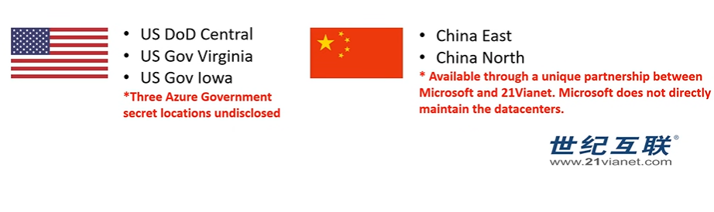

## Availability Zones

* An **Availability Zone** (AZ) is physical location made up of one or more datacenter.
* A datacenter is a secured building that contains hundreds of thousands of computers.
* A region will generally contain 3 AZ.
* Its common practice to run workloads in at least 3 AZs to ensure services remain available in case one or two datacenters fail.
* Azure generates separate billing reports and invoices for each subscription so that you can organize and manage costs. Resource groups can be used to group costs, but you will not receive a separate invoice for each resource group. Management groups are used to efficiently manage access, policies, and compliance for subscriptions. You can set up billing profiles to roll up subscriptions into invoice sections, but this requires customization.

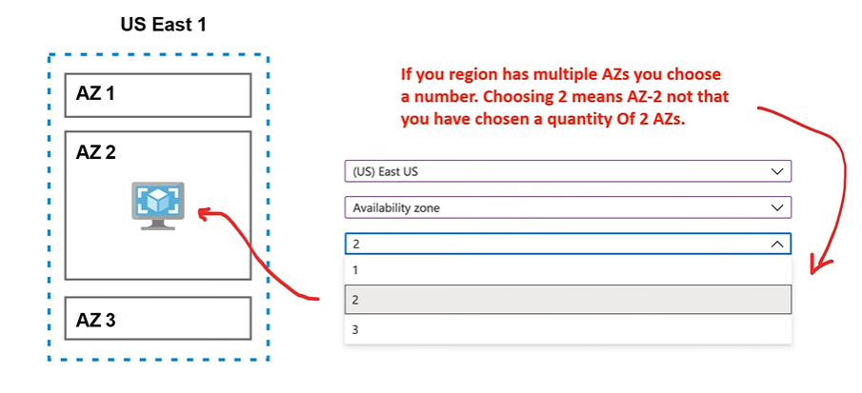

## AZ Supported Regions

* Not every region has support for availability zone. These regions are known as Alternate or Other.
* **Recommended regions** are supposed to have at least 3 AZs.

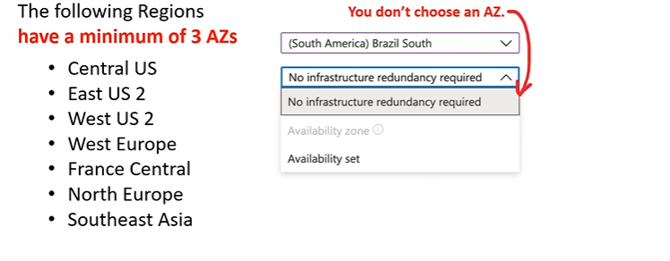

## Fault and Update Domains

* An AZ in an Azure region is a combination of a fault domain and an update domain.
* **Fault Domain**
  + A logical grouping of hardware to avoid a single point of failure within an AZ. Group of VMs that share a common power source and network switch.
* **Update Domain**
  + Azure may need to apply updated to the underlying hardware and software. Update domains ensure your resources do not go offline.
* **Availability Set**
  + A logical grouping that you can use in Azure to ensure that the VMs you place in the Availability Set are different fault/update domains to avoid downtime.

# Support Plans

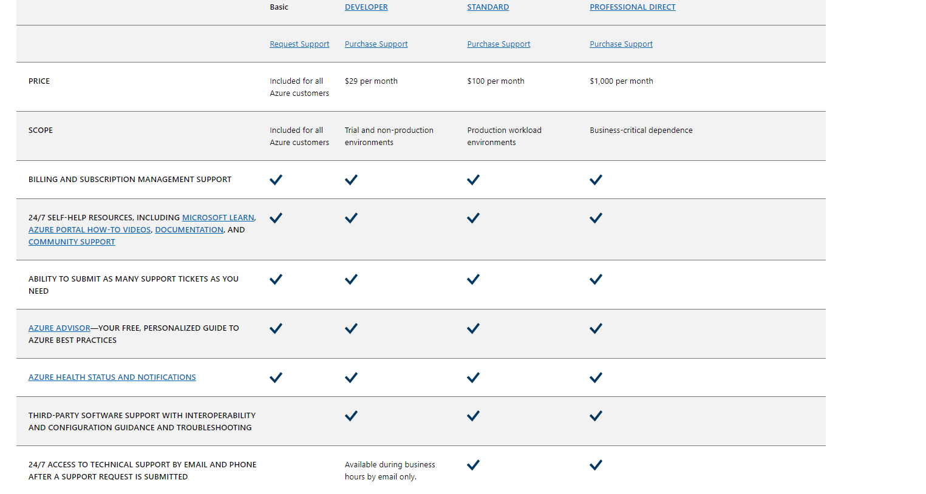

* There Premier is also support plan but exclusively for Enterprises.

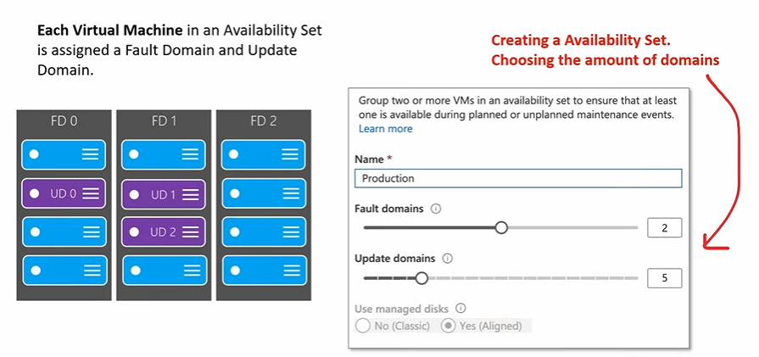

# Computing Services

* **Azure Virtual Machine**
  + Windows or Linux VMs. The most common type of compute. You choose your OS, Memory, CPU, Storage.
  + You share hardware with other customers.
* **Azure Container Instances**
  + **Docker as a Service** Run containerized apps on Azure without provisioning servers or VMs.
  + **There is no auto-scaling or even static scaling in ACI.**
  + **It is Platform as a Service.**
* **Azure Kubernetes Service (AKS)**
  + **Kubernetes as a Service** Easy todeploy, manager and scale containerized apps. Uses the open-source Kubernetes (K8) s/w.
  + **It is a Platform as a Service.**
  + **Highly scalable and customizable.**
* **Azure Service Fabric**
  + **Tier 1 Enterprise containers as a Service**
  + Distributed systems platform. Runs in Azure or on-premises. Easy to package, deploy and manage scalable and reliable **microservices.**
* **Azure Functions**
  + Event-driven, serverless compute (functions) run code without provisioning or managing servers.
  + It **is PaaS.**
  + You pay only for the computer time you consume.
  + Serverless functions are little bites of code that we just upload to make it work and we do not have to think about servers or provisioning anything. These functions run for very short duration.
  + It scales nicely and with consumption bases pricing it is ideal for hosting applications with an unpredictable workload demand.
* **Azure Batch**
  + Plans, schedules and executes your batch computer workloads across running 100+ jobs in parallel.
  + Use Spot VMs to save money (previously used Low-priority VMs to save on compute)
  + There are VMs which are underutilized so Azure allows us to rent them at a lower cost affective price.

## Azure DevTest Labs

* Azure DevTest Labs is a service for easily creating, using, and managing infrastructure-as-a-service (IaaS) virtual machines (VMs) and platform-as-a-service (PaaS) environments in labs.
* Labs offer preconfigured bases and artifacts for creating VMs, and Azure Resource Manager (ARM) templates for creating environments like Azure Web Apps or SharePoint farms.
* DevTest Labs creates labs consisting of pre-configured bases or Azure Resource Manager templates.
* By using DevTest Labs, you can test the latest versions of your applications by doing the following tasks:
  + Quickly provision Windows and Linux environments by using reusable templates and artifacts.
  + Easily integrate your deployment pipeline with DevTest Labs to provision on-demand environments.
  + Scale up your load testing by provisioning multiple test agents and create pre-provisioned environments for training and demos.

## Azure Virtual Machines

* Choose an OS, compute, memory and storage and launch a server in minutes.
* Azure Virtual Machines (VMs) is highly configurable server.
* It is Infrastructure as a Service (IaaS).
* Virtualization let you run a server **without having to buy and maintain the physical hardware** that runs it.
* VM still require maintenance such as:
  + Applying OS system patches
  + Installing and configuring packages
* The size of VM is determined by the Image. The image defines the combination of vCPUs, memory and storage capacity.
* The current limit on a per subscription bases is **20 VMs per region**.
* Azure VMs are billed at an hourly rate.
* A single instance VMs has an availability of 99.9% (when all storage disks are premium).
* **Two instances deployed in Availability Set will give you 99.95% availability**.
* You can attach multiple Managed Disk to your Azure VMs.

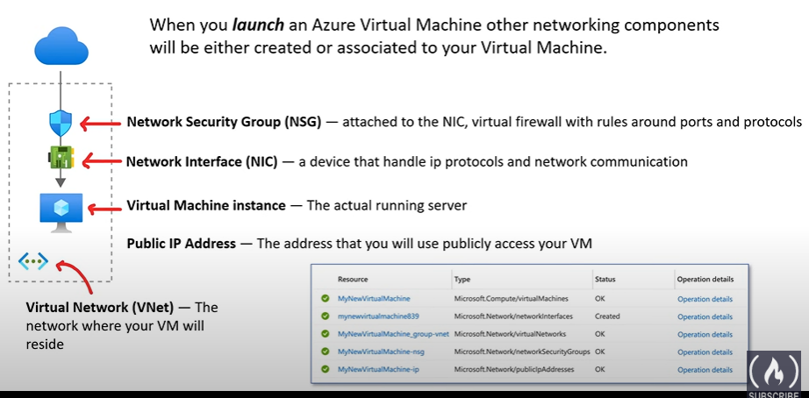

### Network Security Groups (NSGs)

Network security groups allow you to filter network traffic to and from Azure resources in a virtual network. By associating NSGs with the subnets containing your web servers and database servers, you can define inbound and outbound security rules to permit or deny traffic based on various criteria such as source IP address, destination IP address, port, and protocol.

With NSGs, you can effectively control the communication flow between the web servers and database servers, ensuring that only the necessary connections are allowed while restricting access to unauthorized traffic.

A Network Security Group (NSG) can be used to **filter inbound and outbound network traffic to and from Azure resources**, including virtual machines. By creating an NSG and associating it with both the web server and database server, you can configure the NSG rules to allow traffic only between the two servers, ensuring that any other traffic to the database server is blocked.

### Azure VM – Operating System

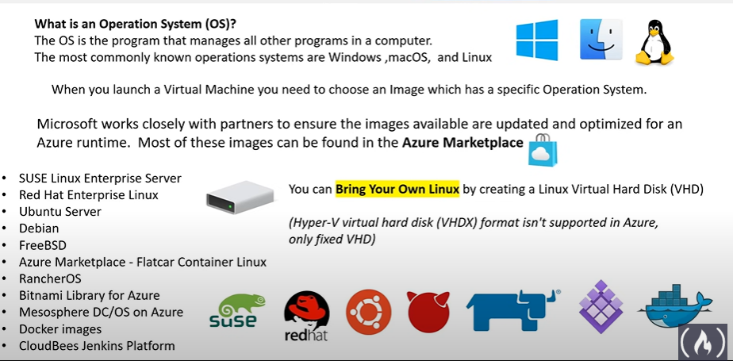

## Azure Scale Sets

* Azure Scale Sets allows you to automatically increase or decrease your VM capacity.
* It is an IaaS.

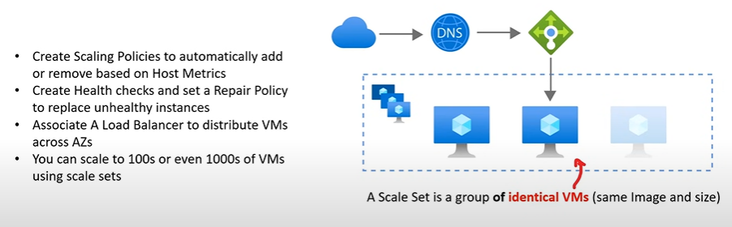

### Load Balancer

* There are 2 different load balancers we can use.
* **Application Gateway** is a **HTTP/HTTPS** web traffic load balancer with URL-based routing, SSL termination, session persistence, and web application firewall.
* **Azure Load Balancer** supports all **TCP/UDP** network traffic, port-forwarding, and outbound flows.

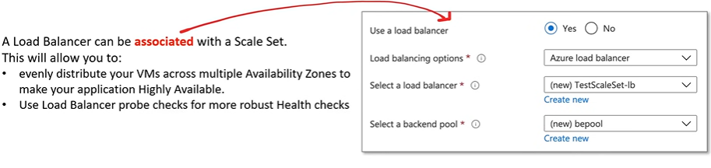

### Scaling Policy

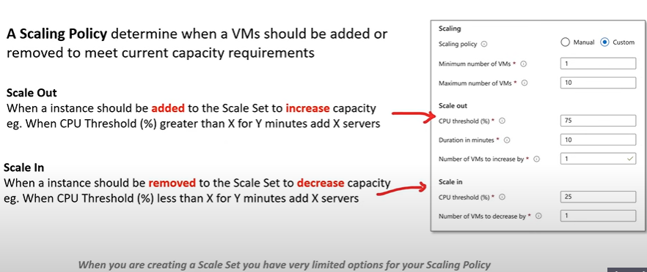

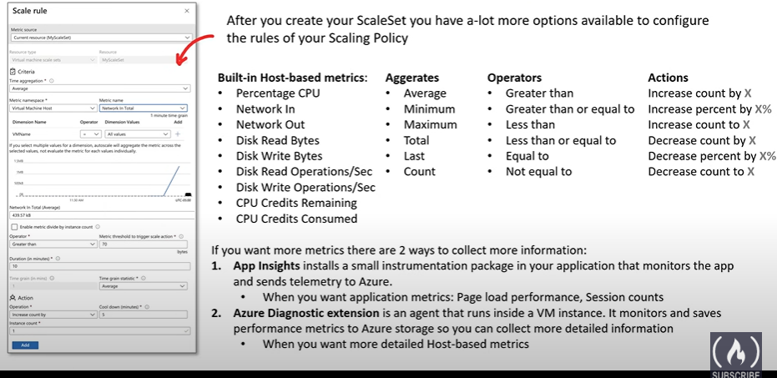

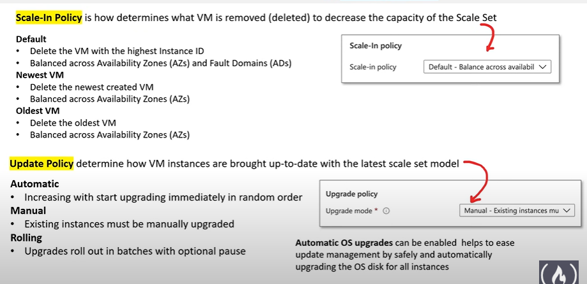

### Health Monitoring

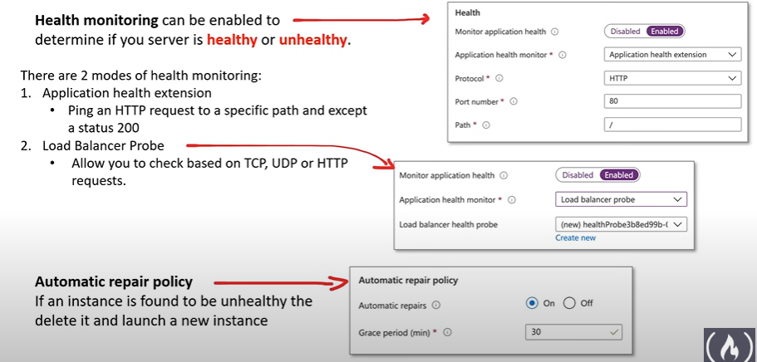

## Azure Virtual Desktop

* Formally known as Windows Virtual Desktop
* It is a **desktop and app virtualization** service that runs on cloud.
* It works across devices like Windows, Mac, iOS, Android, and Linux, with apps that you can use to access remote desktops and apps.
* You can use most modern browsers to access Azure Virtual Desktop-hosted experiences.

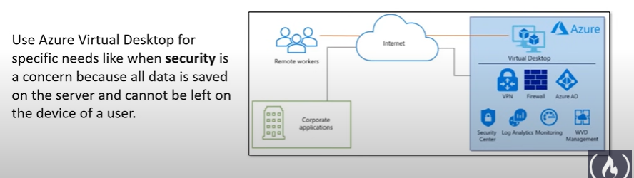

### Advantages

* **Enable secure and productive remote work on any device.**
  + It provides full Windows 10 and Windows Server desktop and application virtualization on any personal device.
  + Seamless integration with Microsoft 365 Apps for enterprise and Microsoft Teams
* **Reduce costs of licensing and infrastructure.**
* **Protect against outages to stay productive.**
  + Help keep your team running during outages by leveraging build-in Azure Site Recovery and Azure Backup technologies.
* **Simplify IT management.**
* **Keep application and user data secure.**
  + Easily apply the right access controls to users and devices with **Azure Active Directory Conditional Access.**

# Azure App Services

* Quickly **deploy and manage Web apps** on Azure without worrying about the underlying infrastructure.
* This is known as **Platform as a Service**.
* **Azure App Service** is an **HHTP-based service** for hosting web applications, REST APIs, and mobile back ends.
* You can choose your **programming language** and either a **Windows** or **Linux** environment.
* It is a **Platform as a Service,** so it’s the Heroku equivalent for Azure.

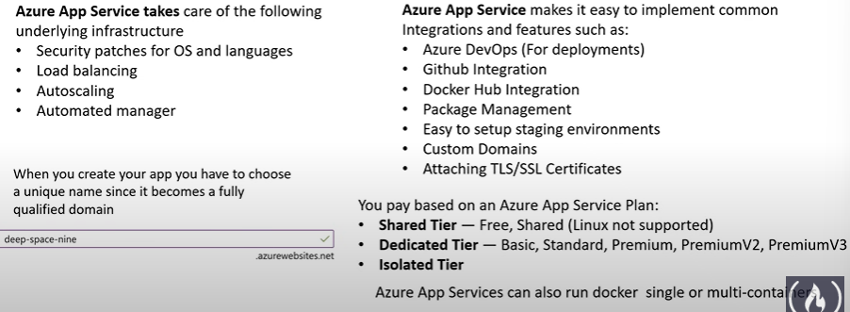

## Runtimes

* A runtime software/instruction that are executed while your program is running.
* A runtime generally means that **programming language** and **libraries** and **framework** you are using.
* A runtime for Azure App Services will be a pre-defined container that has your programming language and commonly used library for that language installed.

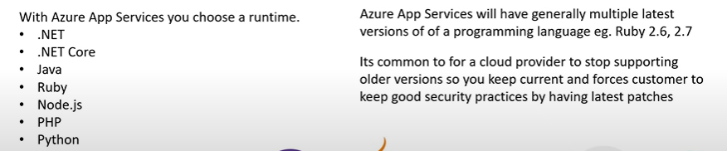

## Custom Containers

* Azure App Service allows you to define **custom containers** for **Windows** or **Linux.**
* You might want to create your own custom container to use a different runtime or bundle in a packages or software.

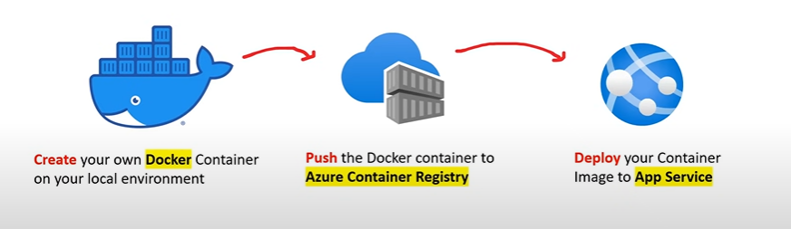

## Deployment Slots

* **Deployment Slots** allow you to create different environments for your web-application associate to a different hostname. This is useful when need a staging, or QA environment.

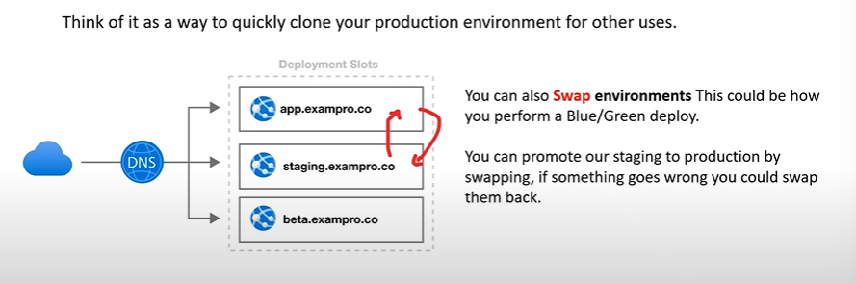

## App Service Environment

* **App Service Environment** (ASE) is an Azure App Service feature that provides a **fully isolated and dedicated environment** for securely running App Service apps at high scale.

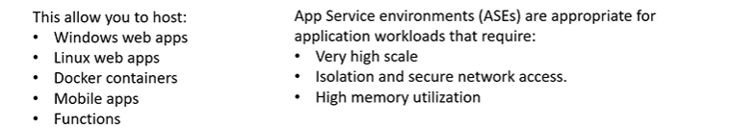

* Customers can create multiple ASEs within a single Azure Region or across multiple Azure regions making ASEs ideal for **horizontally scaling stateless application tires** in support **of high requests per second (RPS) workloads.**
* ASE comes with its own pricing tire which is **Isolated Tier.**
* ASEs can be used to configure security architecture
* Apps running on ASEs can have their access fated by upstream devices, such as web application firewalls (WAFs)
* ASEs can be deployed into Availability Zones (AZ) using **zone pining.**
* There are 2 deployment types for an ASE:
  + External ASE
  + ILB (Internal Load Balancer) ASE

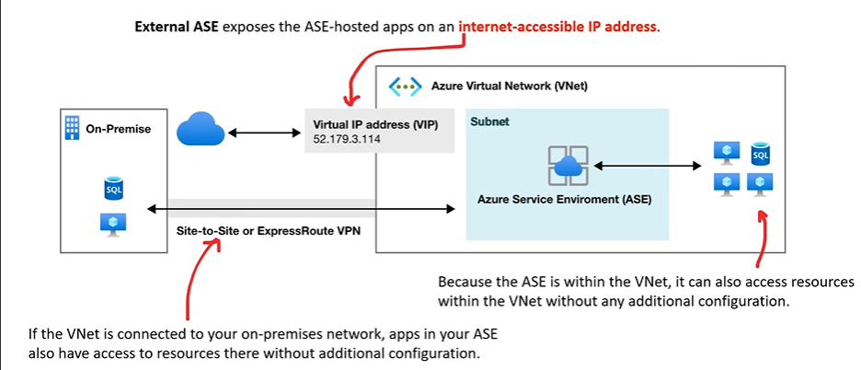

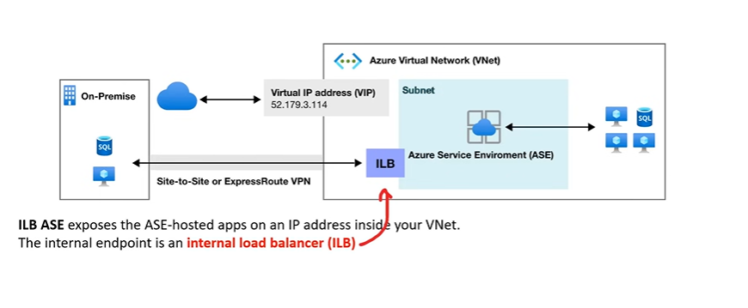

## Azure App Service Plan

* **Azure App Service Plan** defines **how your pay and what resources** are available to you.
* There are **3 pricing tiers** for App Service Plan:

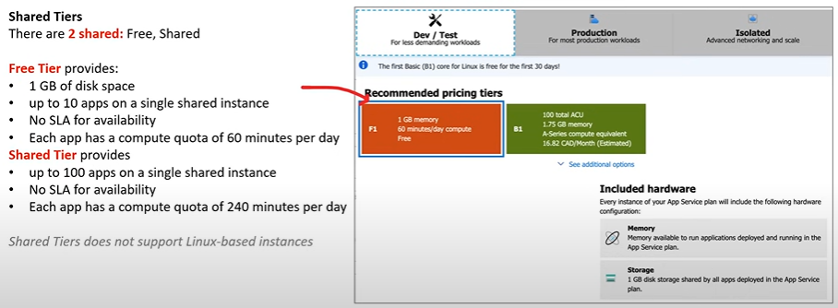

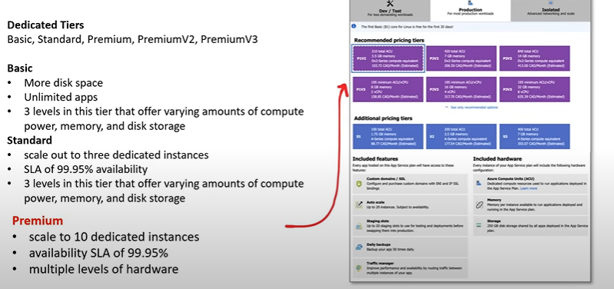

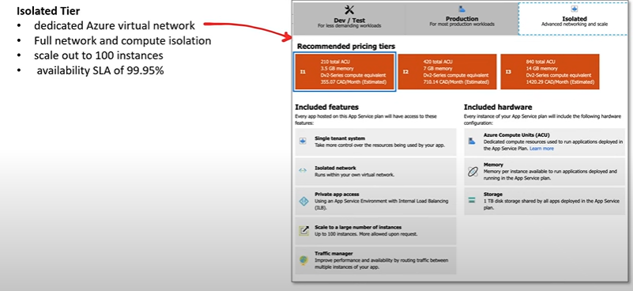

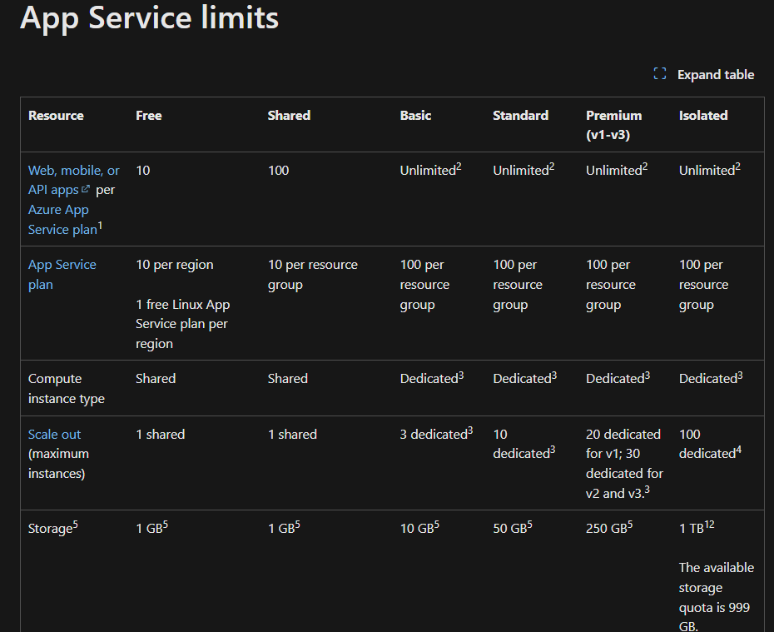

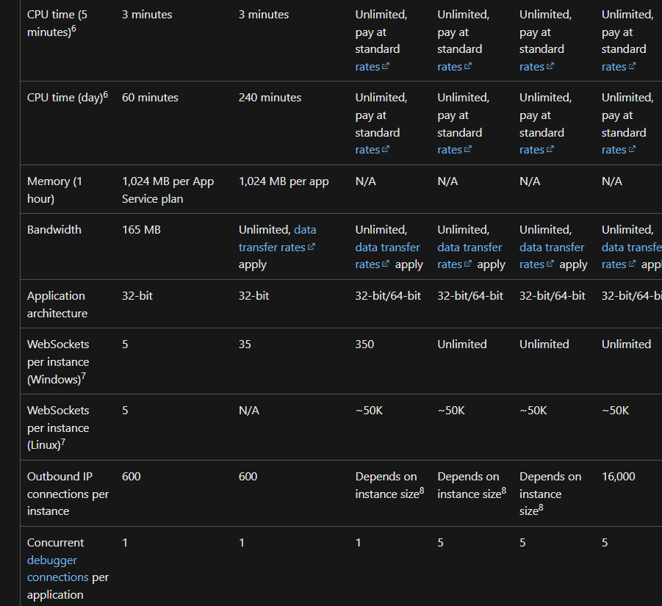

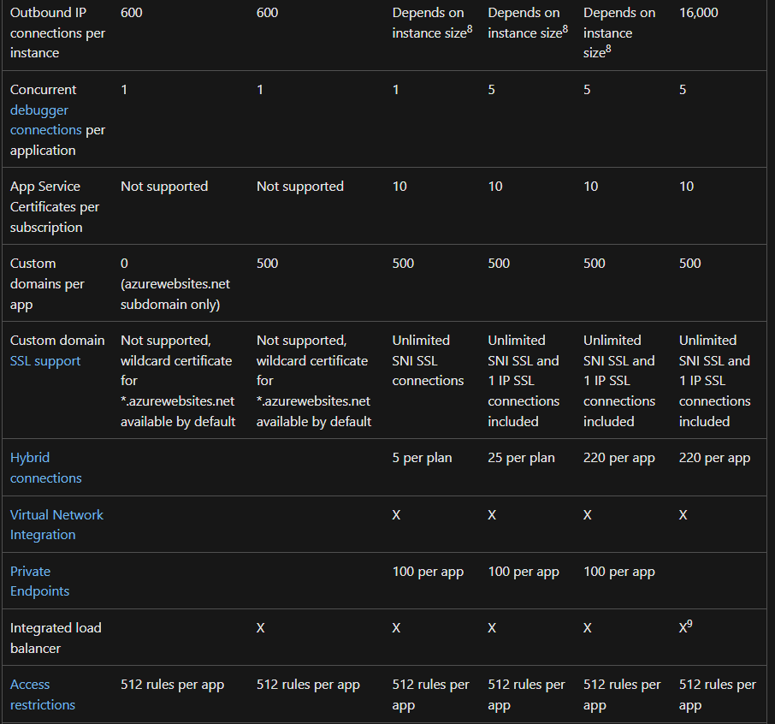

## Internet Information Service (IIS)

**Internet Information Services (IIS)** for Windows® Server is a flexible, secure and manageable **Web server** for hosting anything on the Web. From media streaming to web applications, IIS's scalable and open architecture is ready to handle the most demanding tasks.

# Azure Container Instances (ACI)

* **Package**, **deploy**, and **manage** cloud applications using **containers.**
* **Fully Managed Docker as a Service**
* **It is a Platform as a Service.**
* ACIs allow you to launch containers without the need to worry about configuring or managing the underlying virtual machine.
* ACI is designed for isolate containers:
  + Simple applications
  + Task automation
  + Build jobs
* Containers can be provisioned **within seconds** where as VMs can take several minutes
* Containers are **billed per second** where as VMs are billed per hour (greater savings)
* Containers have **granular and custom sizing for vCPUs, Memory and GPUs** where VMs sizes are predetermined
* ACI can deploy both **Windows and Linux** containers
* You can **persist storage with Azure Files** for your ACI containers
* ACIs are accessed via a fully qualified domain name (FQDN) e.g. customlabel.azureregion.azurecontainer.io.

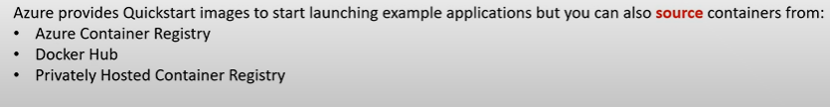

## Container Group

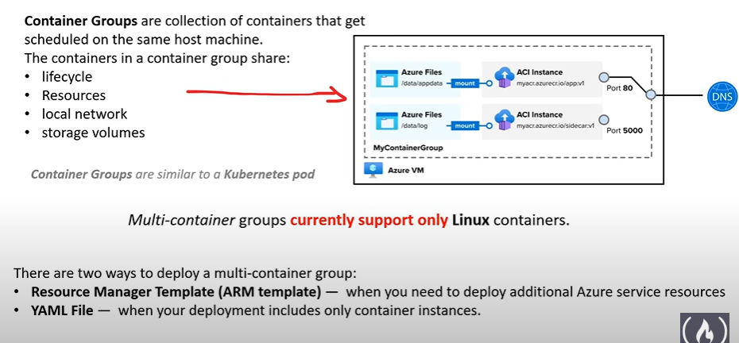

## Container Restart Policies

* A container restart policy specifies what a container should do when their process has completed.
* Azure Container Instances has 3 restart-policy options:
  + **Always** (default): Containers are always restarted. Suited for long running tasks e.g. web-servers
  + **Never**: Containers run one time only. Suited for one off tasks. E.g. background jobs
  + **OnFailure**: Containers that encounter an error

## Container Environment Variables

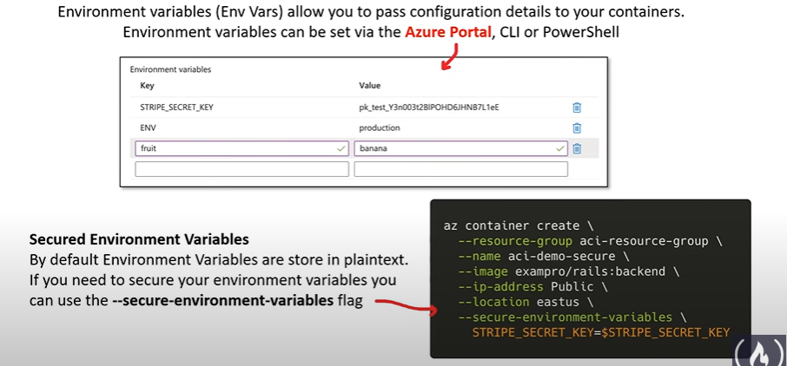

## Container Persistent Storage

* Azure containers are stateless by default.
* When a container creases or stops all state is lost. To persist state, you need to mount an external volume.
* You can mount the following external volumes:
  + Azure Files
  + Secret Volume
  + Empty Directory
  + Cloud git repo

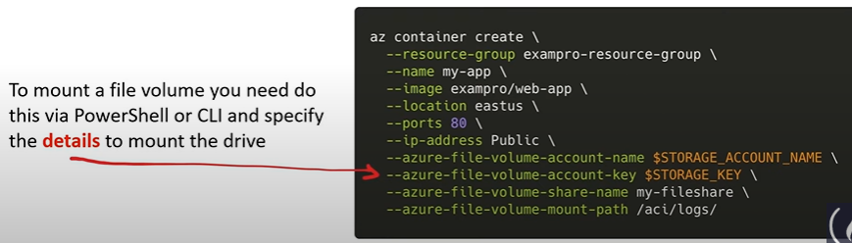

# Azure Virtual Network

* Virtual Network (vNet) is a logically isolated section of the Azure Network where you launch your Azure resources.

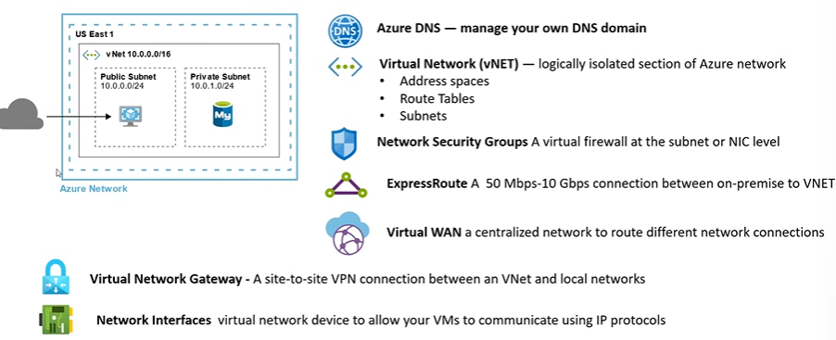

## VNeT Peering

* VNET peering is when you connect multiple VNet so they act as one network.

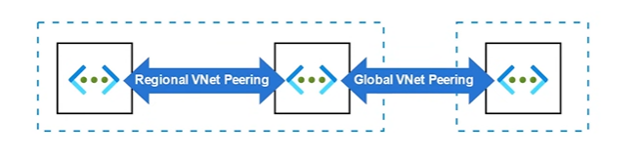

* There are 2 types of VNET peering
  + **Regional VNet Peering** is when you peer two VNets from the same region
  + **Global VNet Peering** is when you peer two VNets from two different regions
* VNet peering enables you to seamlessly connect Azure virtual networks. Once peered, the VNets appear as one, for connectivity purposes.
* The traffic between virtual machines in the peered virtual networks is routed through the Microsoft backbone infrastructure, much like traffic is routed between virtual machines in the same VNet, **through private IP addresses** only.
* **No public internet is involved**. You can peer VNets across Azure regions, too – all with a single click in the Azure Portal.

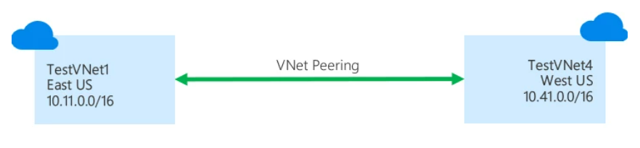

## Network Interfaces

* **Software or hardware interface** between two pieces of equipment or protocol layers in a computer network is called Network interface.
* **Network Interface Controller** (NIC) is a computer hardware component that connects a computer to a computer network.
* Also known as:
  + Network interface car
  + Network adapter
  + LAN adapter
  + Physical network interface.
* NICs communicate using **Internet Protocol (IP)**

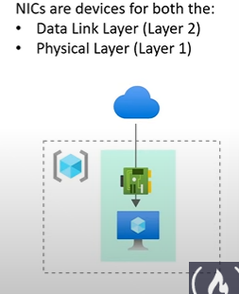

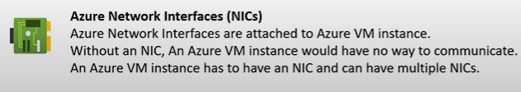

## Subnets

* A subnet is **a logical division of an address space**. Subnets help you define different kinds of workloads and allows you to apply virtual isolation within your network. When you launch an Azure resource you choose the subnet you want to launch within and an IP from that subnet is assigned to your resource.
* Subnets can’t be nested.
* A subnet needs a **Route Table** so it can access the internet or anything else.
* Public and Private subnet describes whether a subnet is reachable from the internet or not.
* Azure **has no concept of private and public subnets** and its up to you to configure your subnets to have ensure they do not reach the internet by ensuring they have no route via their route table to the Internet Gateway.
* You can associate a **Network Security Group** to protect traffic entering and leaving your subnet by applying security rules that can allow or deny access based on IP address, port, and protocol
* Azure has a special type of Gateway Subnet that is used by **Azure Virtual Network Gateway** and that service launches specialized VMs into that subnet.

# Azure DNS

* An Azure Domain Name Server is a service that is responsible for **translating or resolving a service name** to its IP address.
* Azure DNS is a **hosting service** for **DNS domains** that provides name resolution by using Microsoft Azure infrastructure.



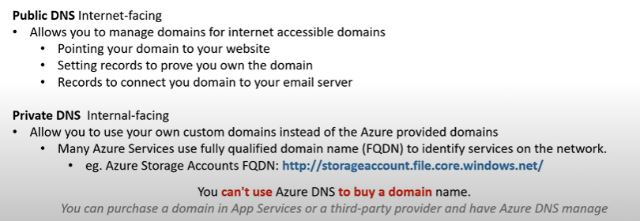

# Virtual Network Gateways

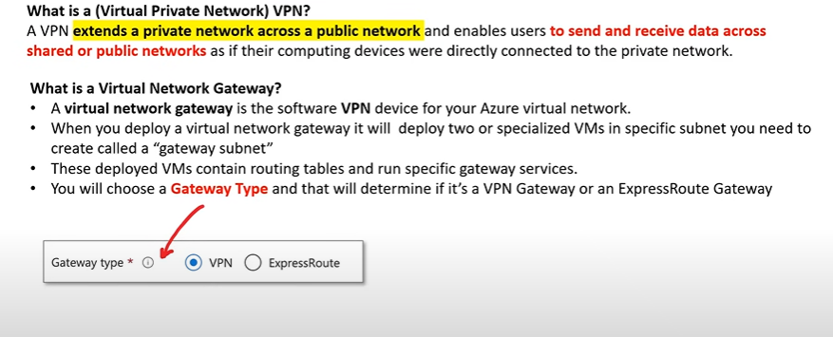

# Azure Express Routes

* **Azure ExpressRoutes** creates **private connections** between Azure datacenters and infrastructure on your premises or in a colocation environment.
* ExpressRoute connections don’t go over the public internet and as a result can offer: **more reliability, faster speeds, consistent latencies, higher security**
* Connectivity can be from an:
  + Any-to-any (IP VPN) network
  + A point-to-point Ethernet networks
  + Virtual cross-connection
* The connection is through a connectivity provider at a **colocation facility**

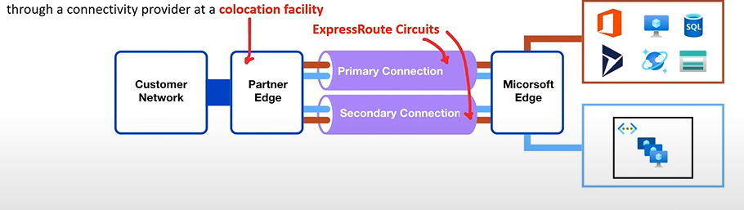

* There are multiple expressroute circuits so that we can achieve high availability just in case the other one goes out.
* We can route the traffic through two places:
  + Microsoft Peering for Office 365, Dynamics 365, Azure Public Services (Public IP)
  + Azure Private Peering for VNets
* **ExpressRoute Direct** allows for **greater bandwidth connections** from 50 Mbps to 10Gbps. Ideal where for hybrid solutions with massive amounts of data or where latency matters.

# Private Links

* Azure Private Links allows you to **establish secure connections** between Azure resources so traffic **remains within the Azure Network**.

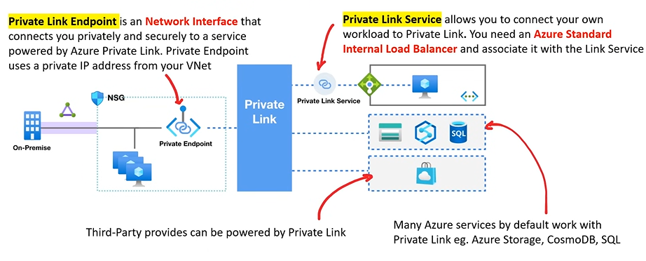

# Storage Services

## Azure Blob Storage



* **Object Serverless Storage**. Store very large files and large amounts of **unstructured** files.
* Pay for what you store, unlimited storage, no-resizing volumes, filesystem protocols.
* Blob stands for **B**inary **L**arge **OB**ject, which refers to a collection of binary data stored as a single entity.

## Azure Disk Storage



* A virtual volume. Choose SSD or HDD, encryption by default, attach volume to VMs.

## Azure File Storage



* A shared volume that you can access and manage like a file server. It has protocols like SMB. The reason we want this storage is when we require to use a single storage shared by multiple servers or VMs. Or when we have users who want to access the storage using the **SMB** or similar protocols.

## Azure Queue Storage



* **Messaging Queue**. A data store for queuing and reliably delivering messages between applications.
* It enables applications to communicate and coordinate tasks asynchronously by using messages.

## Azure Table Storage



* **Wide-Column NoSQL Database**. A NoSQL store that hosts semi-structured data independent of any schema.

## Azure Data Box / Azure Databox Heavy



* A rugged briefcase computer and storage designed to move terabytes or petabytes of data.
* Sometimes it is better to move a data physically than over the internet.

## Azure Archive Storage



* Long term cold storage for when you need to hold onto files for years on the cheapest storage options. Cheap because data is being accessed frequently from the disk.

## Azure Data Lake Storage

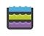

* A centralized repository that allows you to store all your structured and unstructured data at any scale.
* This is designed for big data analytics.
* It combines the scalability and cost-effectiveness of cloud storage with features tailored for analytics, making it an ideal solution for storing and analyzing large amounts of structured and unstructured data.

# Azure Storage Accounts

* Contains all of your Azure Storage data objects: **blobs, files, queues, tables, and disk**
* Azure Storage Account **is Platform as a Service**.

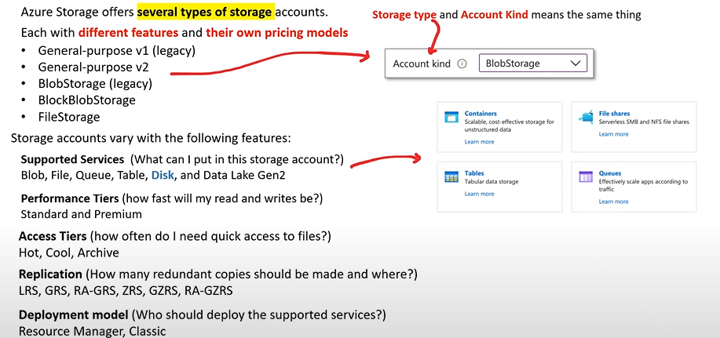

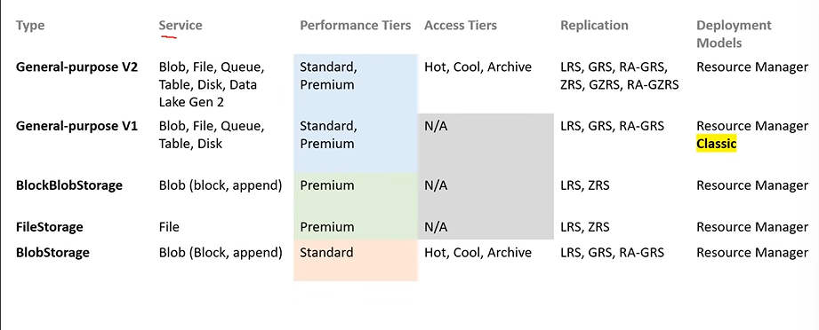

## Core Storage Services

Azure has **5 core storage** services

* **Azure blob**



* + A massively scalable **object store** for text and binary data.
  + Also includes support for big data analytics through Data Lake Storage Gen 2
* **Azure Files**



* + Managed **file shares** for cloud or on-premises deployments
* **Azure Queues**



* + A **messaging store** for reliable messaging between application components
* **Azure Tables**



* + A **NoSQL store** for schema less storage of structured data.
  + Storage for semi-structured data:
    - No need for foreign joins, foreign keys, relationships or strict schema
    - Designed for fast access
* **Azure Disks**



* + **Block-level storage** columns for Azure VMs

## Performance Tiers (Blob Storage)

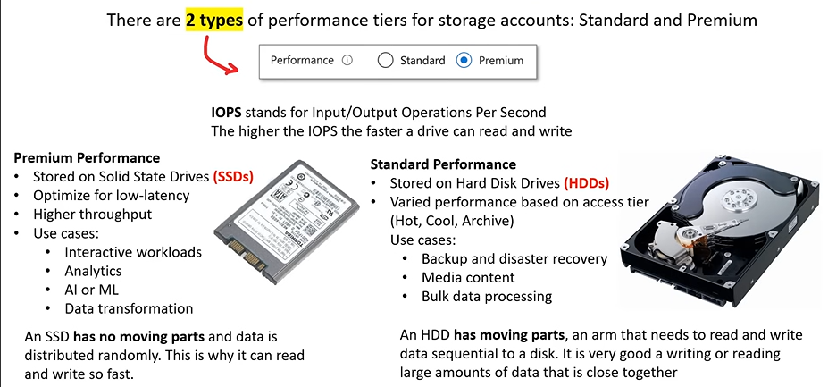

## Access Tiers (Blob Storage)

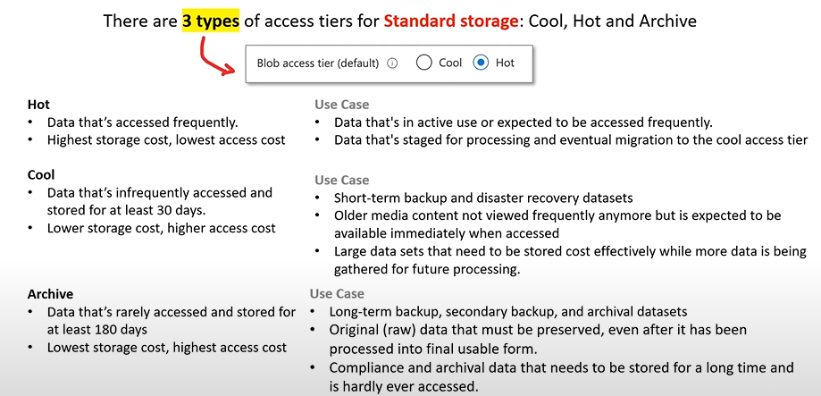

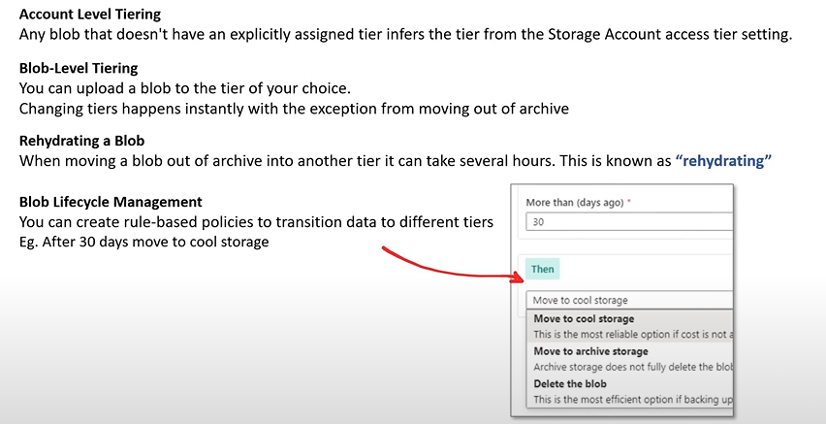

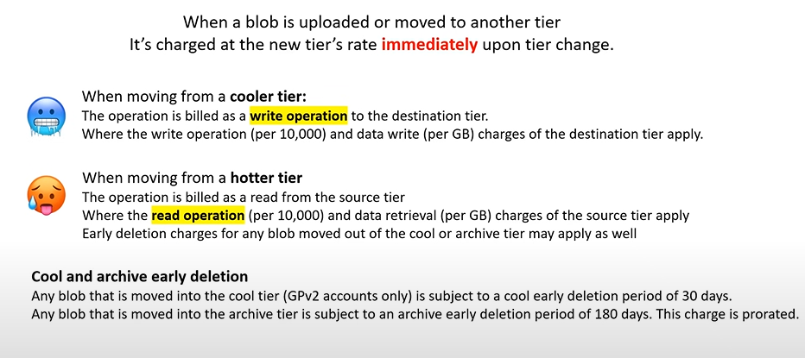

## Replication and Data Redundancy

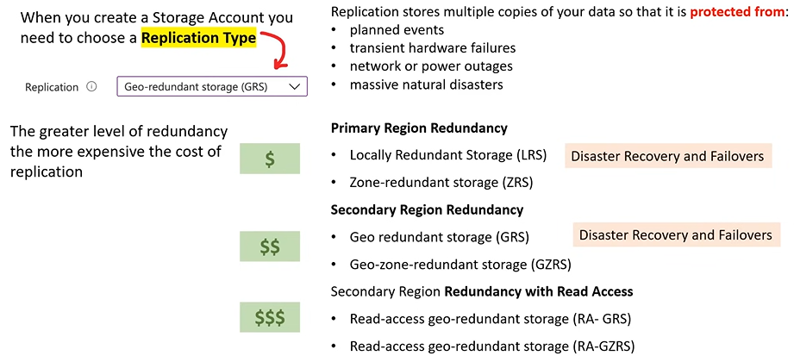

### Locally Redundant Storage (LRS) and Zone Redundance Storage (ZRS)

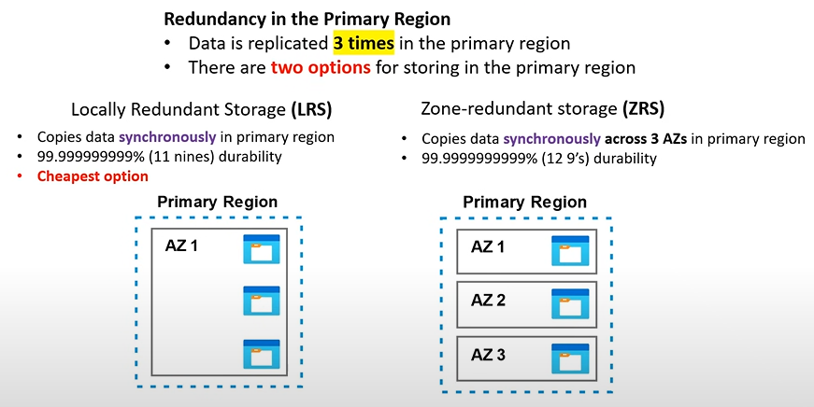

**Synchronously means that all the servers have the same data and asynchronously means that there might be some discrepancy between servers i.e. one server might has updated data but the other does not.**

### Geo-Redundant Storage (GRS) and Geo-Zone-Redundant Storage (GZRS)

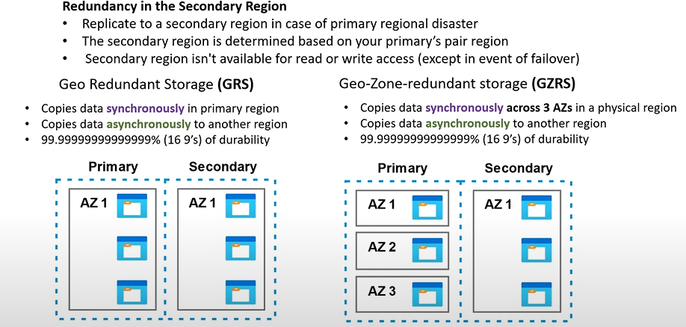

### Read Access Geo-Redundant Storage (RA-GRS) and Read Access Geo-Zone-Redundant Storage (RA-GZRS)

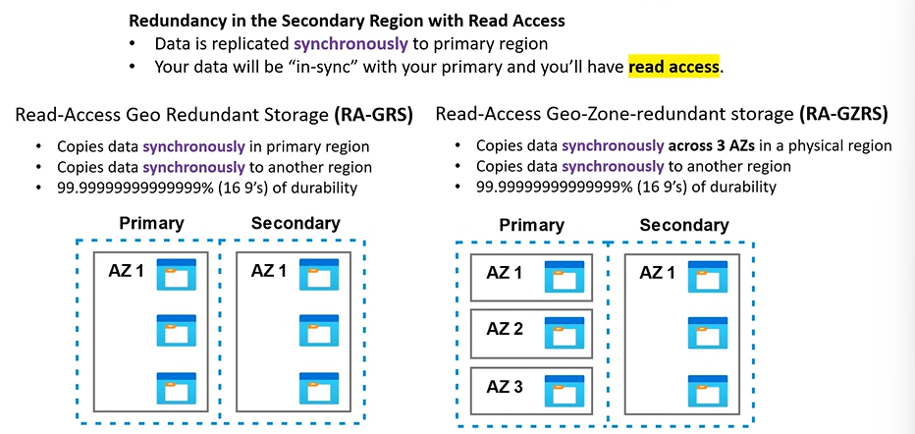

## Azure Blob



* Blob storage is a **object-store** that is optimized by **storing massive amounts of unstructured data**.
* Unstructured data is data that doesn’t adhere to a particular data model or definition, such as text or binary data.

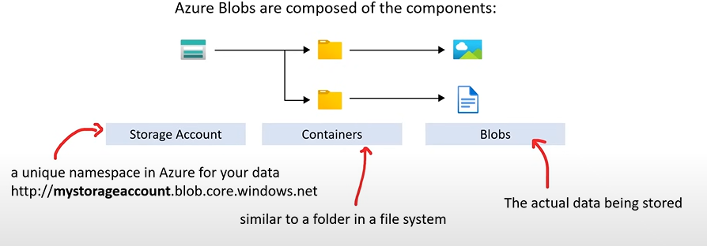

### Azure Blob Types

Azure Storage supports 3 types of blobs:

1. **Block blobs**
   1. Store text and binary data
   2. Made up of blocks of data that can be managed individually
   3. Store up to about 4.75TiB of data
2. **Append blobs**
   1. Optimized for append operations
   2. Ideal for scenarios such as logging data for virtual machine
3. **Page blobs**
   1. Store random access files up to 8 TB in size
   2. Store virtual hard drive files and server as disks for Azure virtual machine

## AZCopy

## Azure Storage Explorer



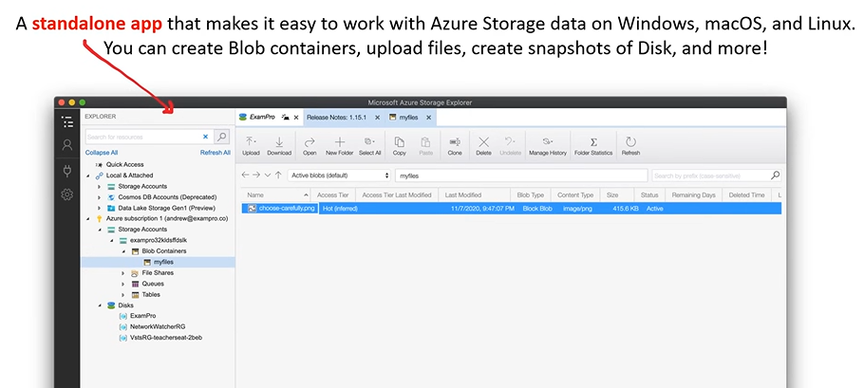

## Azure Files

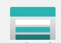

* **Azure Files** is a fully managed **file share** in the cloud
* A file share is a **centralized server for storage** that allows **multiple connections**
* It is like having one big shared drive that everyone (Virtual Machines) can work on at the same time.

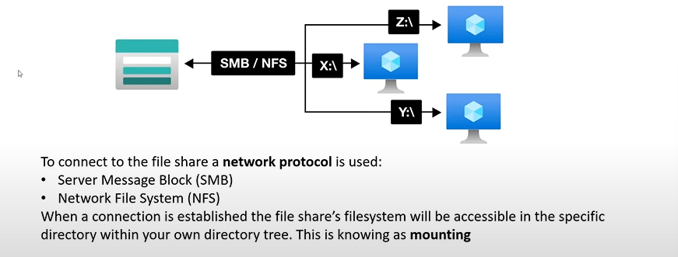

### Use Cases

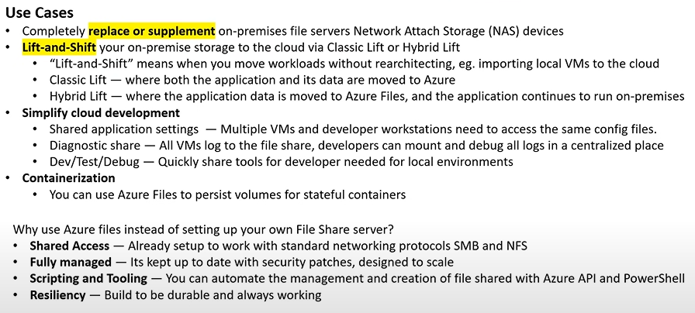

## Azure File Sync

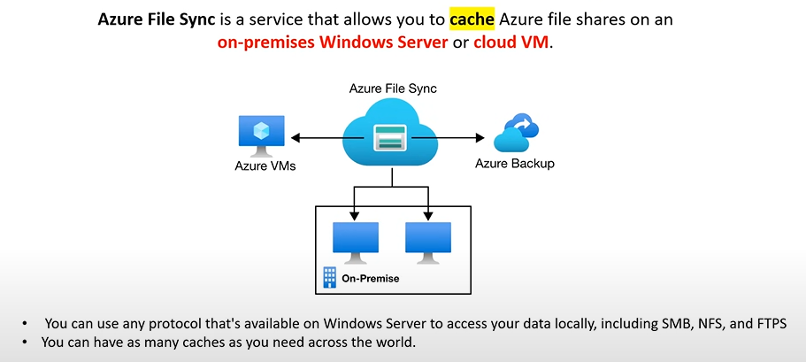

# Azure Cloud Adoption Framework

Cloud Adoption Framework is a whitepaper that is a **step-by-step process** to help organizations plan and migrate their workloads to Azure.

## Define Strategy

* Understand Motivations: grasping the reasons for cloud adoption
* Business outcomes: identifying the desired results
* Business justification: validating the move’s reason
* First adoption project: Kickstarting the cloud journey

## Plan

* Rationalize Digital estate: evaluating current assets
* Initial organization alignment: ensuring everyone is align with the migration goals
* Skills readiness plan: equipping teams with necessary cloud skills
* Cloud adoption plan: laying out the roadmap for cloud adoption

## Ready

* Azure readiness guide: preparing the environment for Azure
* First landing zone: setting up an initial secure Azure environment
* Expand the blueprint: increasing the Azure setup as requirement
* Best practice validation: Ensuring adherence to Azure best practice

### Adopt

#### Migrate

Here the existing workload moves to Azure. It includes

* First workload migration
* Understanding expanded scenarios
* Validating best practices
* Making process improvements

#### Innovate

Transform services into Azure environment using the following:

* Innovation guide
* Exploring new scenarios
* Validating best practices
* Improving new processes

### Govern

* This is about oversight and management.
* Establish a methodology and benchmark for governance
* Implement initial best practices and standards for Azure use
* Measure Governance maturity on how government rules are followed

### Manage

* This deals with on-going operations.
* Ensure business commitments are met during the transition
* Set and assess the operation baseline
* Determine the operations maturity and gage the efficiency of cloud operations

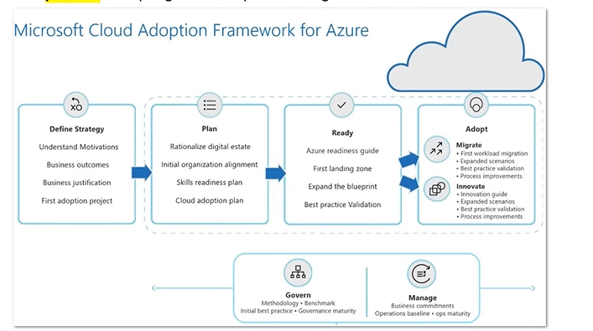

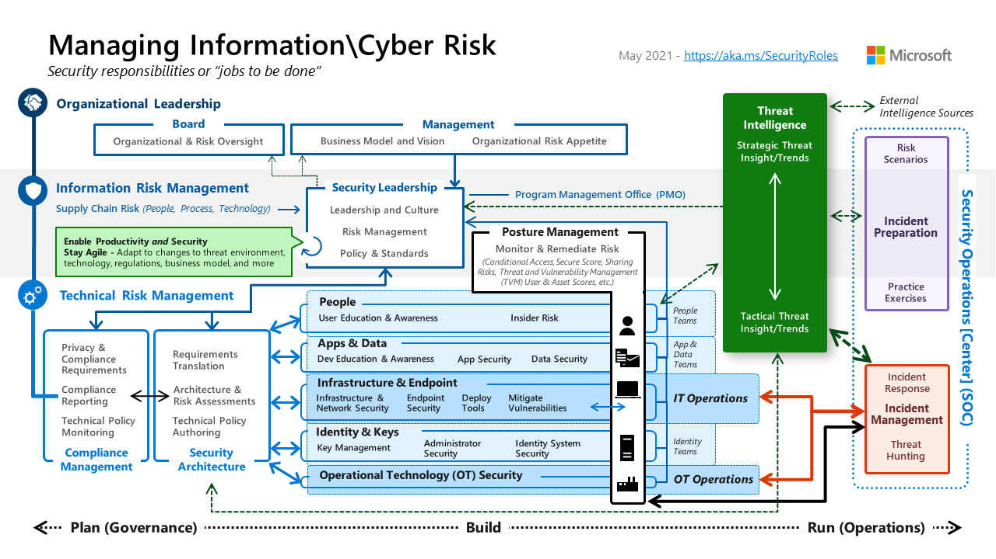

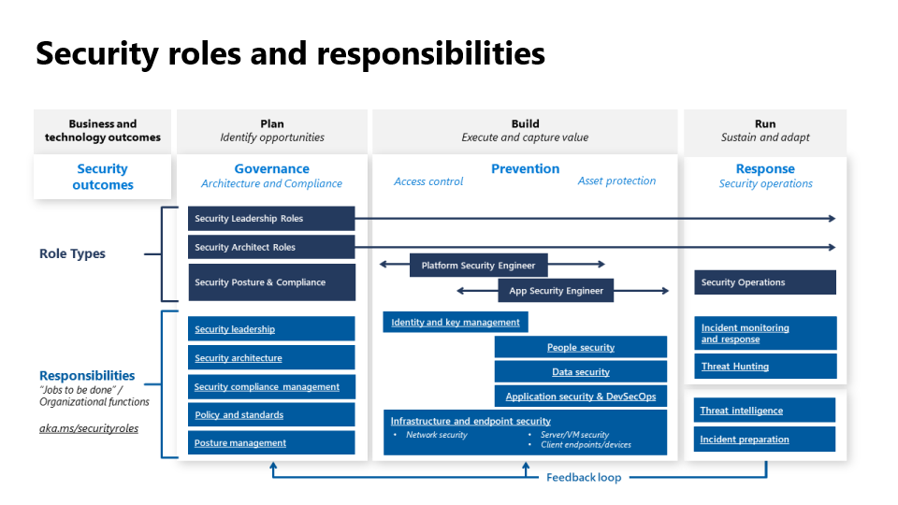

### Roles

* Security Leadership Roles: provide security direction and strategy
* Security architect roles: designs and implements security blueprints
* Platform and App security engineers: design security for platform and apps
* Security operations: manages real time security threats

### Responsibilities

* Security leadership: set security strategy
* Security architecture: design secure systems
* Security compliance management: ensures adherence to regulations
* Policy and standards: set security policies
* Posture management: manages overall security stance

### Phases of Security implementation

* Plan: Identify security needs
* Build: implement strategies including access control and asset protection
* Run: manages ongoing operations including prevention and response
* Feedback loop: continuous improvement cycle and security operation

# Azure Migrate

* **Azure Migrate** offers a streamlined service for **migration, modernization, and optimization** **on Azure.** It simplifies the pre-migration processes like discovering, assessing, and appropriately sizing on-premises resources for infrastructure, data and applications.
* With an extensible framework, Azure Migrate easily integrate with third-party tools, broadening its range of supported scenarios.
* **Unified Migration Platform**: A centralized portal to initiate, execute, and monitor your Azure migration journey
* **Diverse Toolset**: Azure Migrate provides a suite of tools for both assessment and migration. It features tools such as “**Azure Migrate: Discovery and Assessment**” and “**Migration and Modernization**”. It seamlessly integrates with other Azure services, tools and third-party offerings from **independent software vendors (ISVs).**
* **Comprehensive Migration and Modernization Capabilities:** In the Azure Migrate hub, you can **assess, migrate and modernize:**
  + **Servers, databases and Web apps:**  Assess and migrate on-premises servers, web apps, and SQL Server instances to Azure.
    - **Databases:** Analyze on-premises SQL server instances and databases, and migrate them to **Azure SQL** on a VM, **Azure SQL Managed Instance**, or **Azure SQL Database**.
    - **Web Applications:** Evaluate on-premises web applications and transition them to the **Azure App Service or Azure Kubernetes Service.**
    - **Virtual Desktops:** Review your on-site **virtual desktop infrastructure (VDI)** and move it to Azure Virtual Desktop.
    - **Data Transfer:** Efficiently and affordably transfer vast data volumes to Azure using **Azure Data Box** products.

## Azure Migrate – Integrated tools

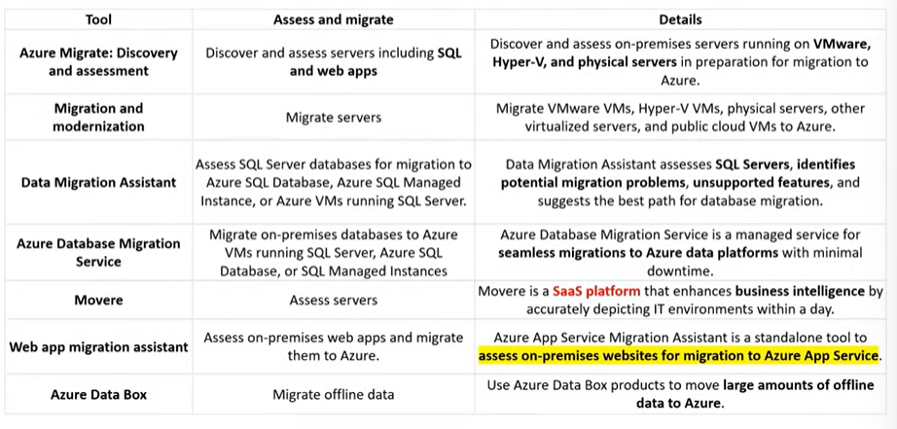

## Azure Databox

* The Microsoft Azure Data Box cloud solution lets you send **terabytes of data into and out of Azure** in a quick, inexpensive, and reliable way.
* Each storage device has a maximum usable storage capacity of **80 TB** and is transported to your datacenter through a regional carrier.
* It is designed to help customers with slow or limited internet connectivity to move large volumes of data to the cloud.

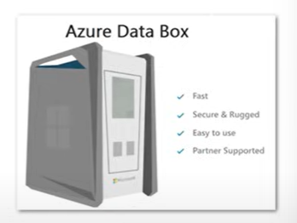

**Use cases**

Data Box is used to **import** data to Azure for:

* **One-time migrations:** Moving large on-premises data, transitioning offline taps, relocating VMs, SQL servers, applications, and transferring historical data for Azure-based analysis.

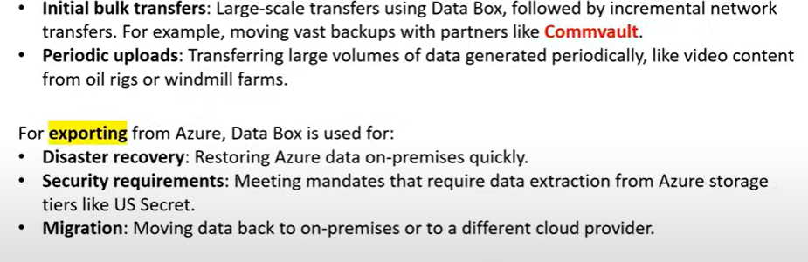

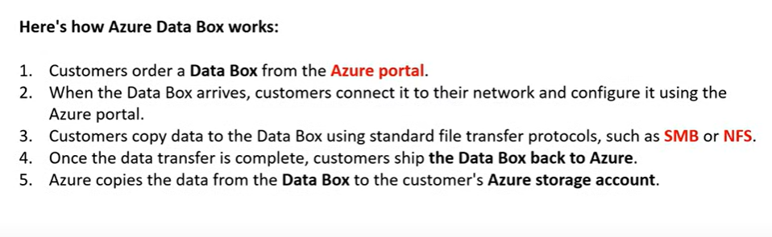

# Microsoft Entra ID (Azure Active Directory)

* Cloud-based **identity and access management** service Manage users, Sign-Ins and access to AD-related resources.
* Azure Active Directory (Azure AD) is Microsoft’s cloud based identity and access management service, which helps your employees sign in and access resources
* External Resources: Microsoft Office 365, Azure Portal, SaaS applications
* Internal resources: Applications within your internal networking, access to workstations on-premise
* Use Azure AD to implement **Single Sign On (SSO).**

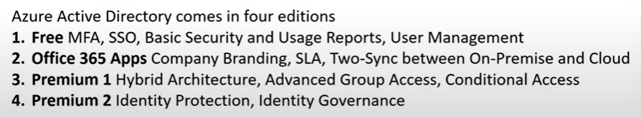

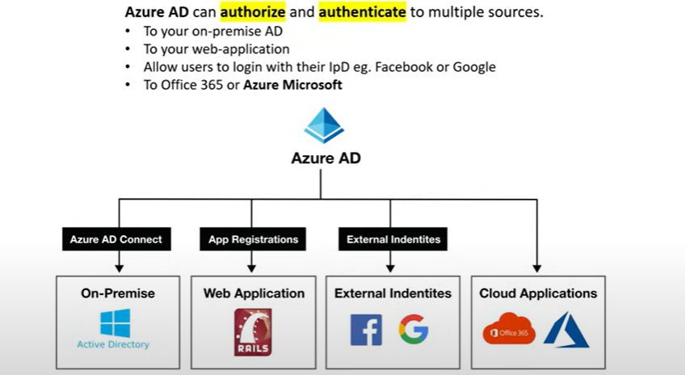

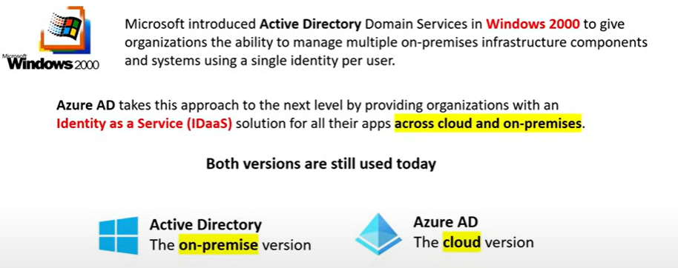

## Active Directory Terminology

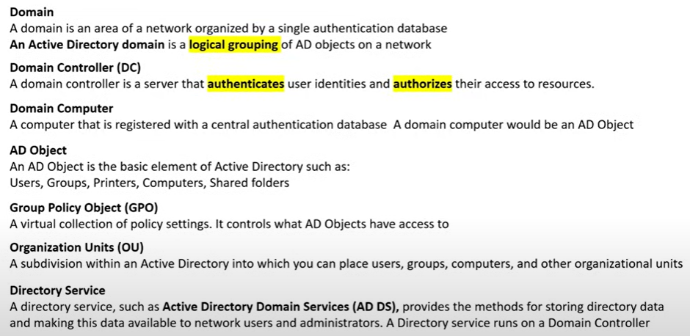

## Azure AD DS

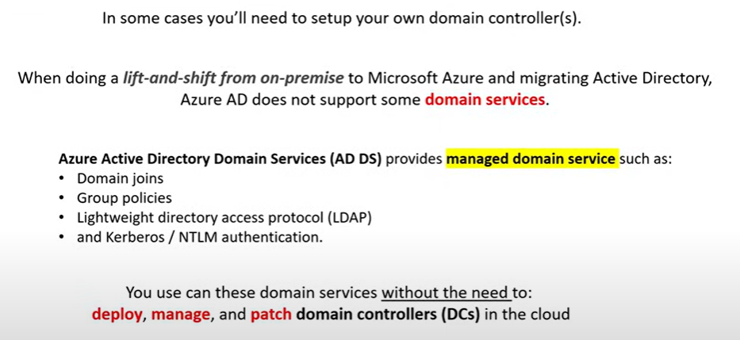

## Single Sign On (SSO)

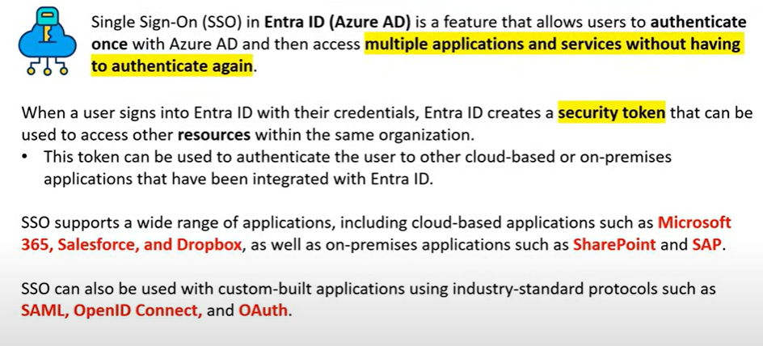

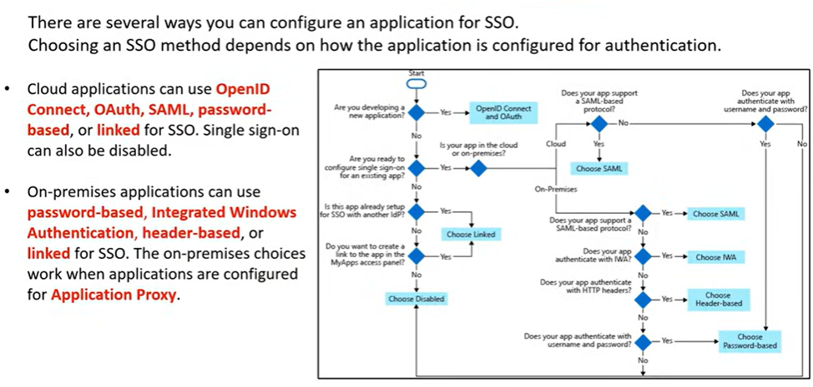

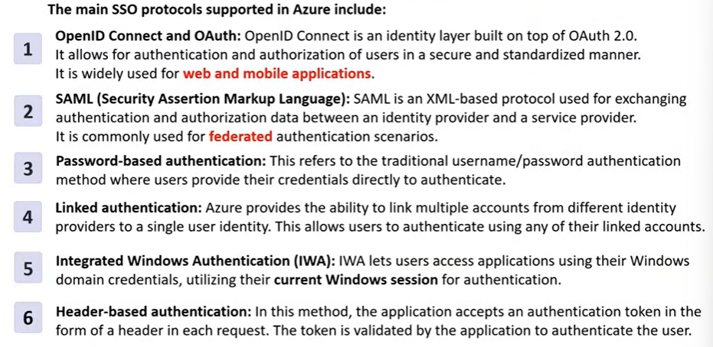

## Multi-Factor Authentication

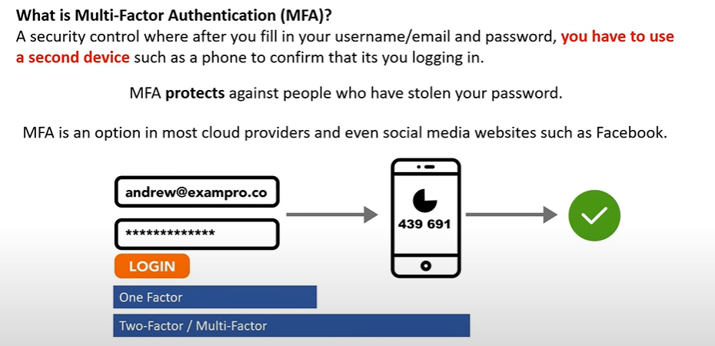

## External Identities

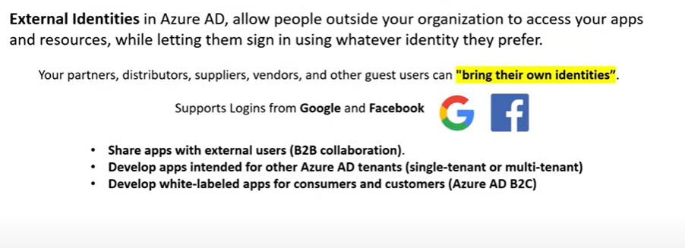

## Conditional Access

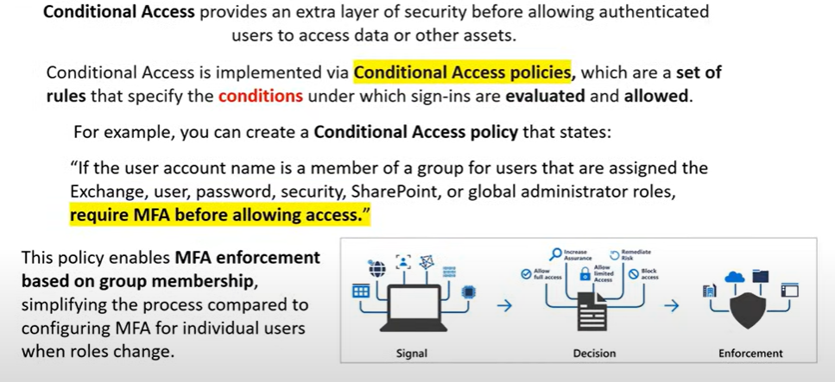

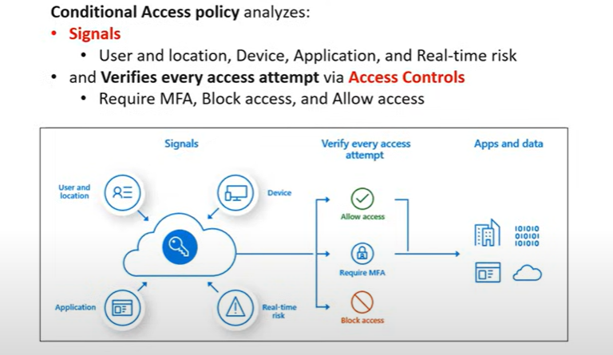

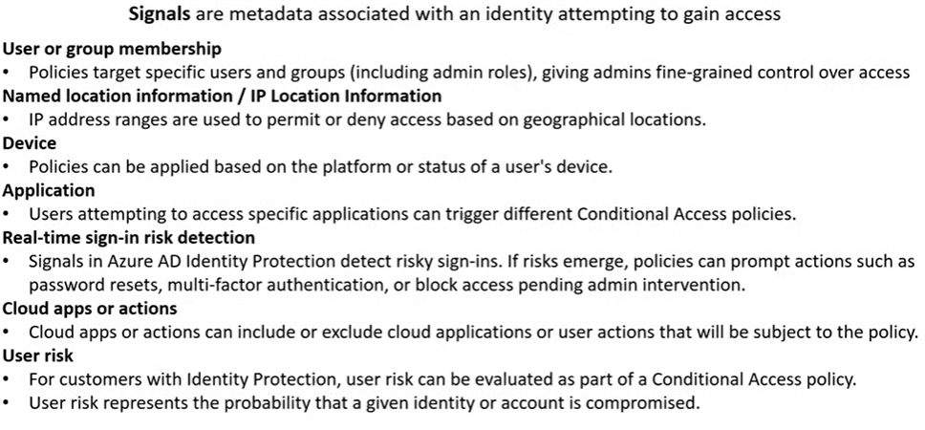

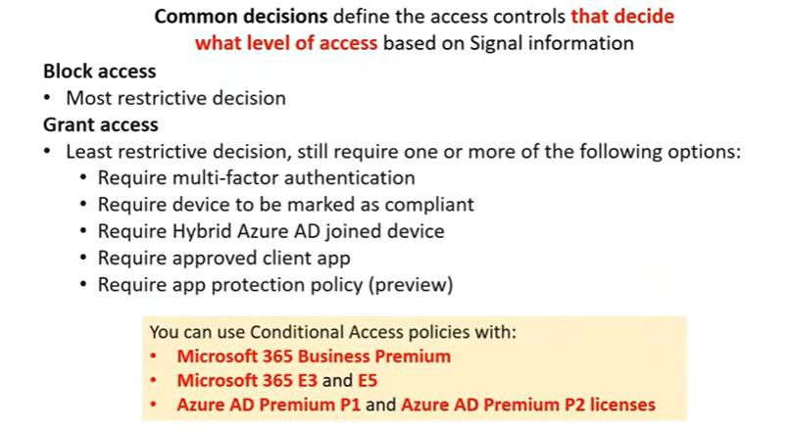

# Zero-Trust Methodologies

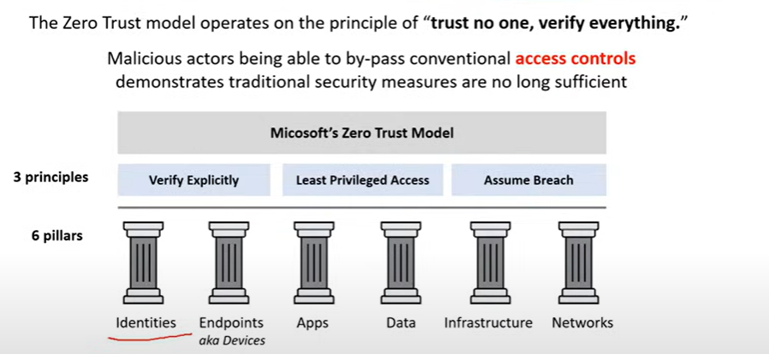

## Principles

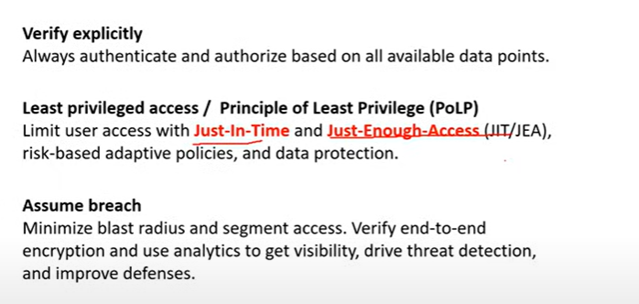

# Defense in Depth

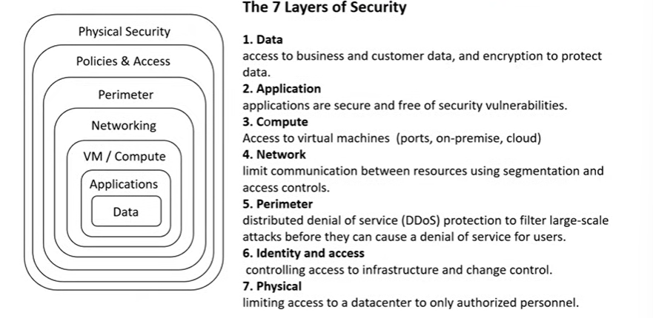

# Azure Defender

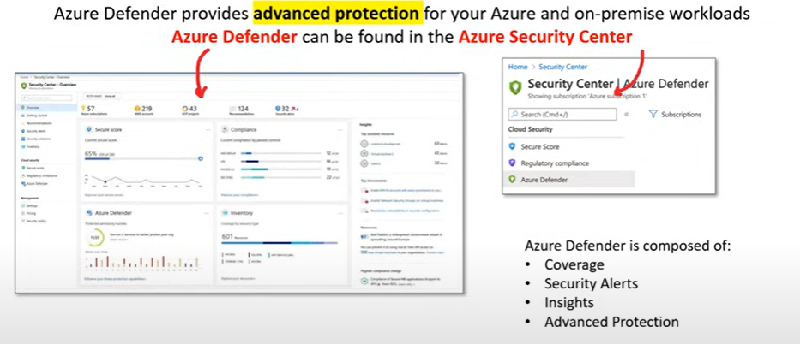

## Coverage

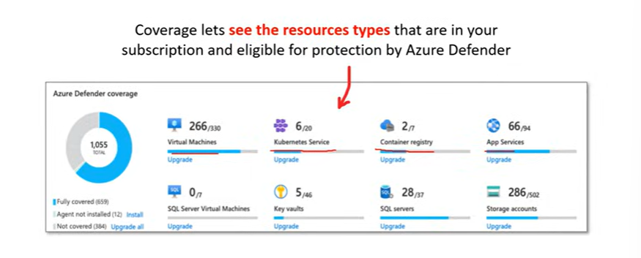

## Security Alerts

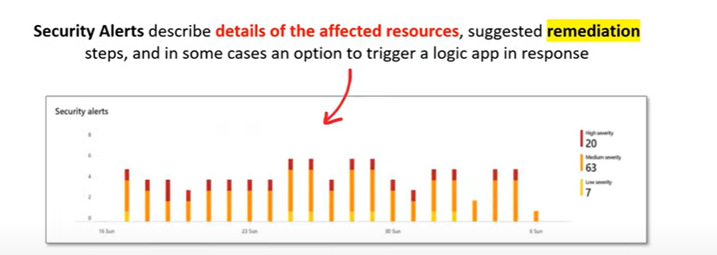

## Insights

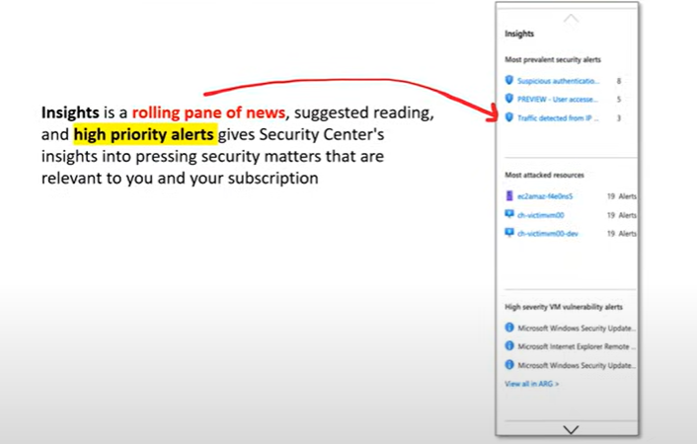

## Advanced Protection

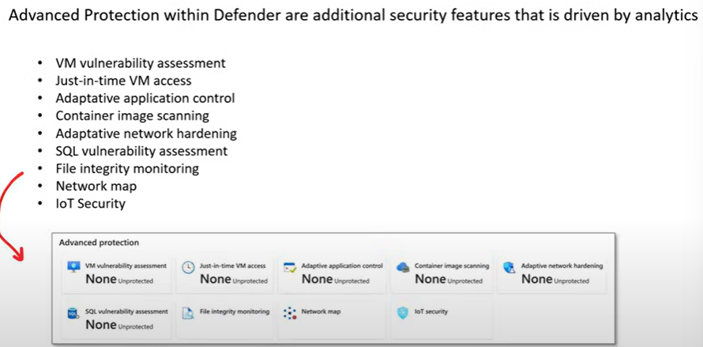

## Scope of Azure Defender

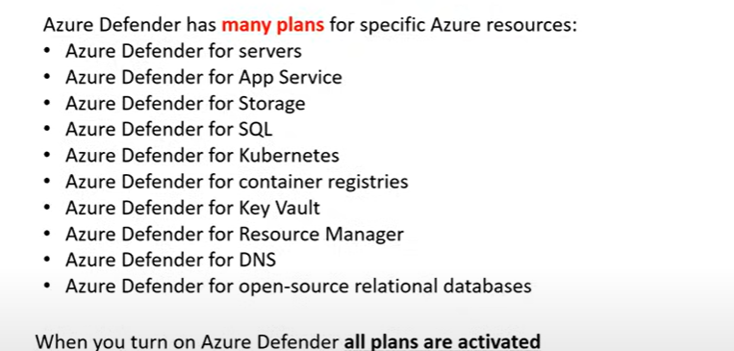

## Network Map

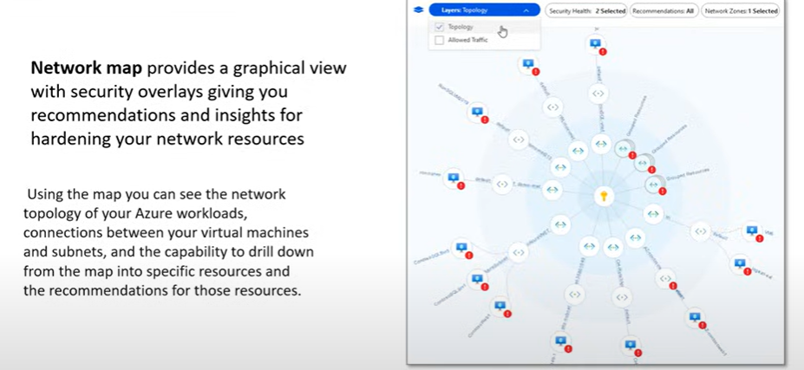

## Azure Arc - Hybrid Cloud Protection

Azure Arc is a hybrid management solution that enables management of on-premises, multi-cloud, and edge environments using Azure services.

It allows you to manage servers, Kubernetes clusters, and applications across on-premises, multi-cloud, and edge environments from a single control plane. With Azure Arc, you can use Azure management services such as Azure Policy, Azure Monitor, and Azure Security Center to manage resources outside of Azure.

It is a control plane that can manage compute resources across cloud service providers, on-premise and at the edge.

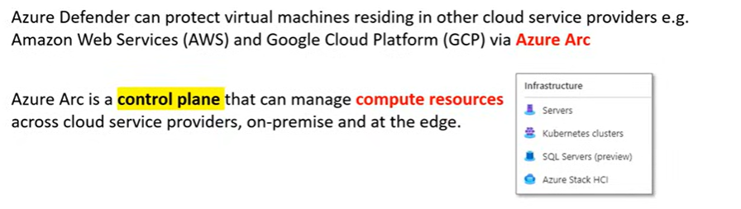

# Multi-Factor Authentication (MFA)

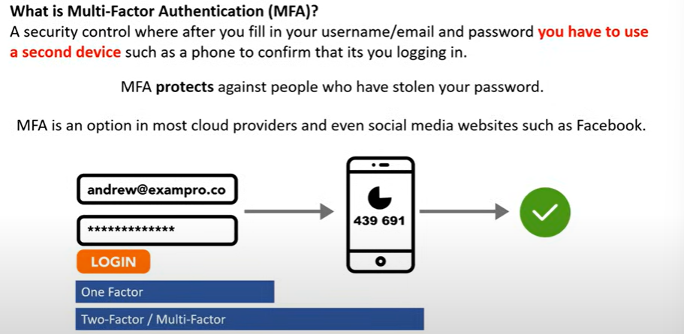

# Azure Security Center

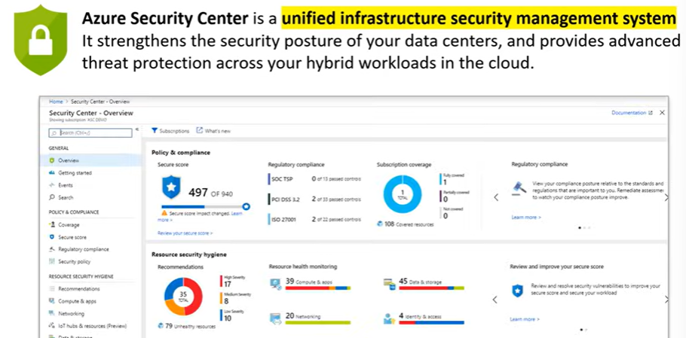

# Key Vault

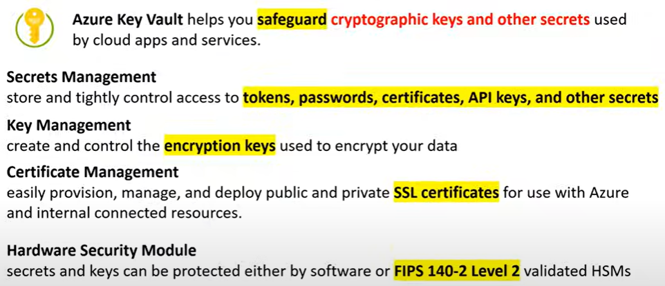

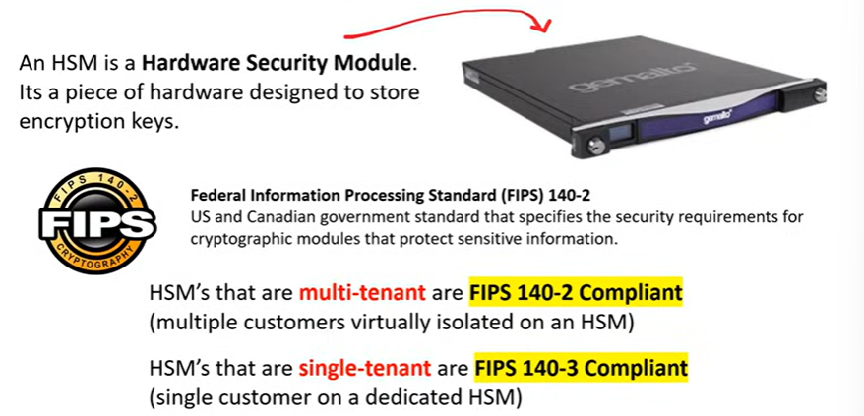

# Azure DDoS Protection

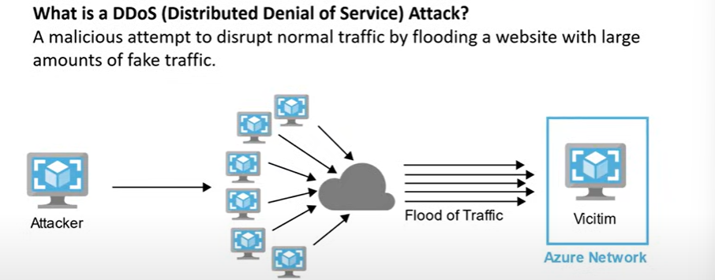

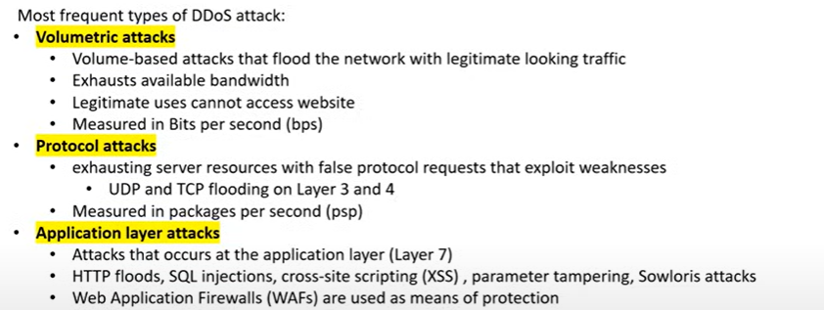

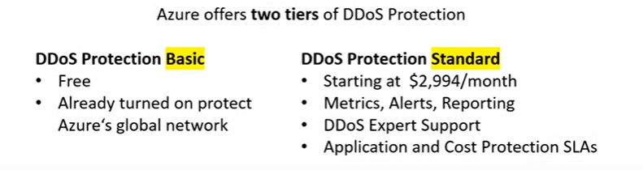

# Azure Firewall

* Firewall is a network security service that monitors and controls incoming and outgoing traffic.
* You can restrict traffic to multiple virtual networks with a single Azure firewall.
* It is **PaaS.**

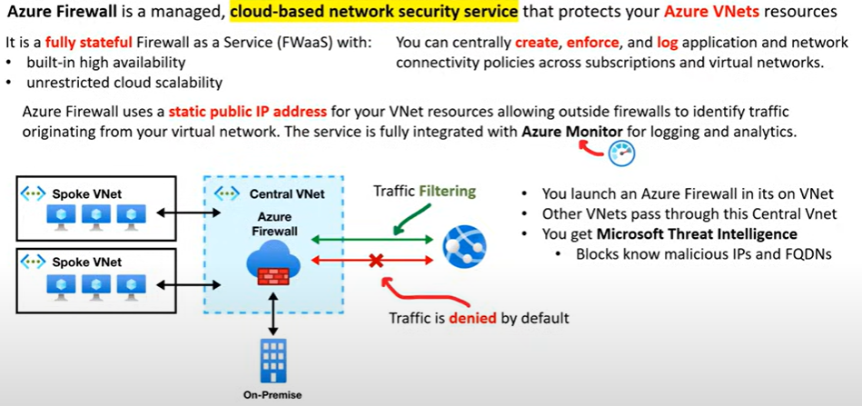

# Azure Site Recovery

Azure Site Recovery helps ensure business continuity by keeping business apps and workloads running during outages. Site Recovery replicates workloads running on physical and virtual machines (VMs) from a primary site to a secondary location. When an outage occurs at your primary site, you fail over to a secondary location, and access apps from there. After the primary location is running again, you can fail back to it.

Azure Site Recovery has an option of High Churn, enabling you to configure disaster recovery for Azure VMs having data churn up to 100 MB/s. This helps you to enable disaster recovery for more IO intensive workloads.

You can set up disaster recovery of Azure VMs from a primary region to a secondary region or from Azure Public MEC to the Azure region or from one Azure Public MEC to another Azure Public MEC connected to the same Azure region.

# Application Gateway

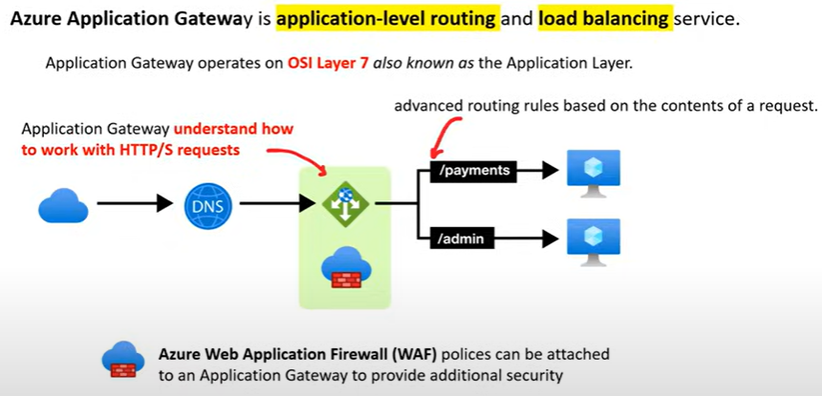

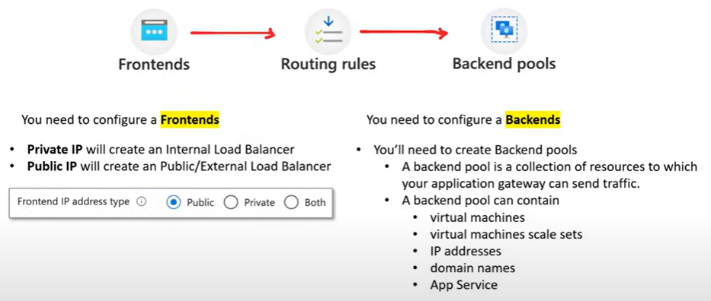

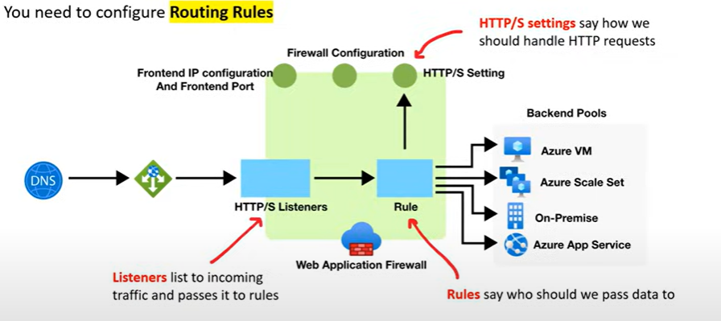

## Routing Rules

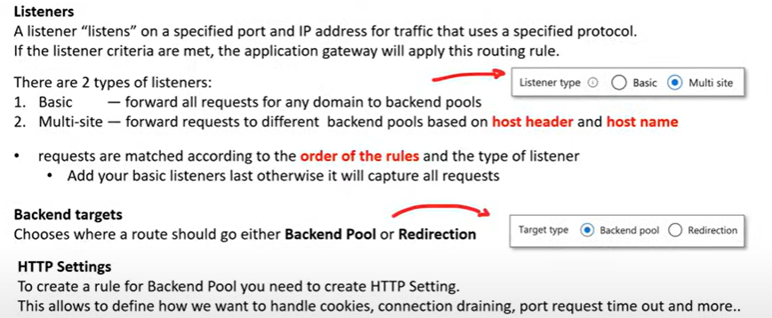

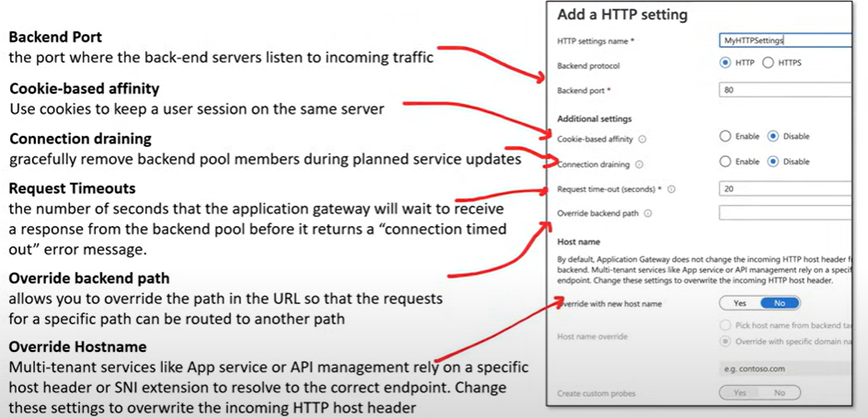

# Azure Role Based Access Control

* It is built on Azure Resource Manager

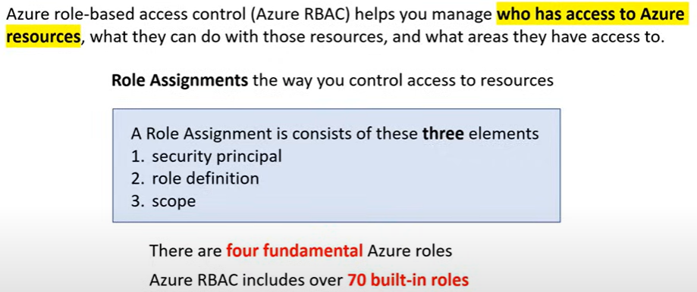

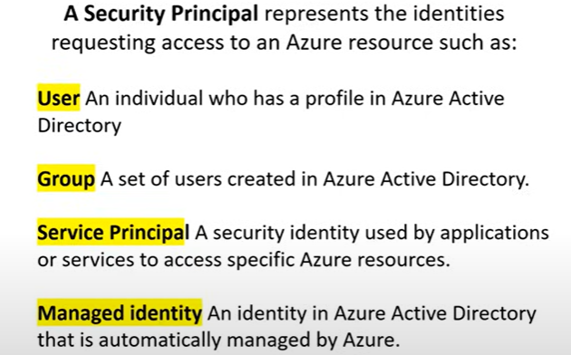

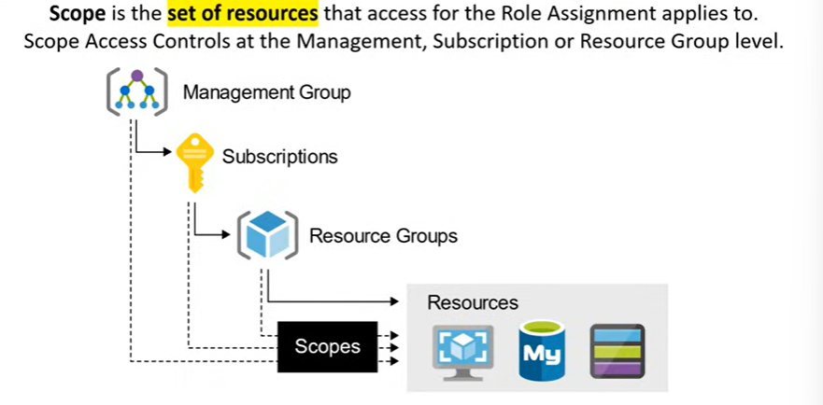

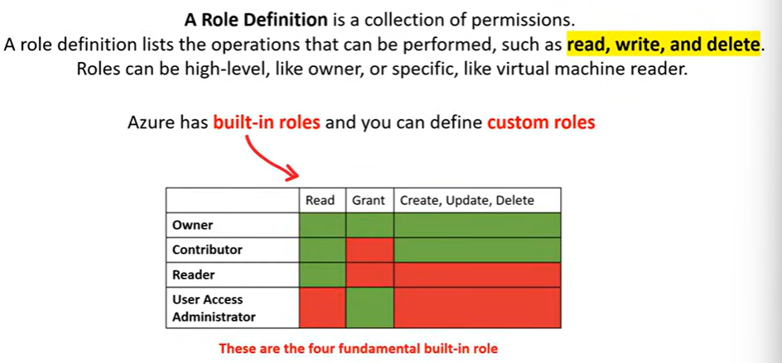

# Azure Management Groups

* Management groups can be used in environments that have multiple subscriptions to streamline the application of governance conditions.
* Resource groups can be used to organize Azure resources. Administrative units are used to delegate the administration of Microsoft Entra resources, such as users and groups. Accounts are used to provide access to resources.

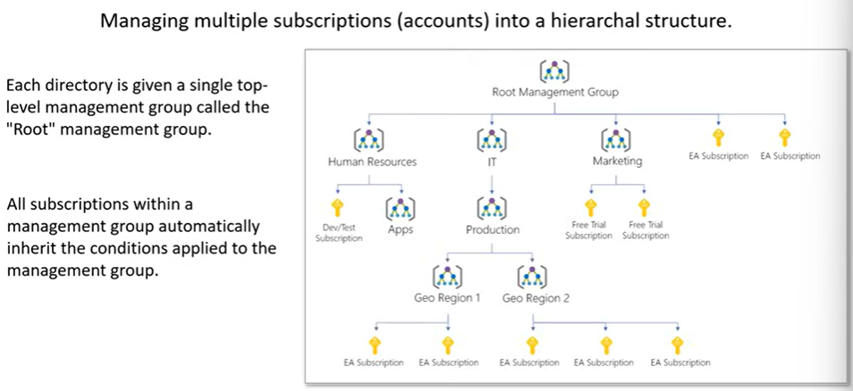

# Service Health

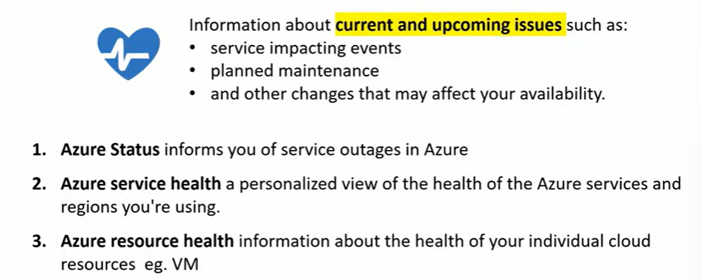

* Health advisories are issues that require that you take proactive action to avoid service interruptions, such as service retirements and breaking changes.
* Service issues are problems such as outages that require immediate actions.

# Azure Advisor

* Personalized consultant service for free.
* Designed to provide recommendations and best practices for
  + Cost (SKU sizes, idle services, reserved instances, etc.)
  + Security (MFA settings, vulnerability settings,etc.)
  + Reliability (previously called High availability) (redundancy settings, etc.)
  + Performance (SKU sizes, SDK versions, etc.)
  + Operational Excellence (service health, subscription limits, etc.)
* Provides actionable recommendations

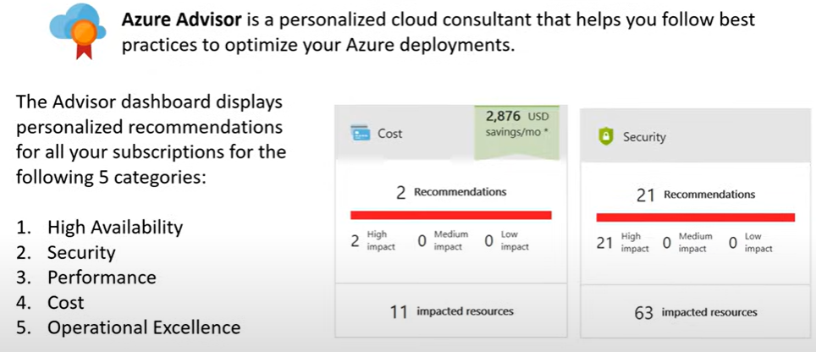

# Database Services

* **Azure Cosmos DB:** A fully managed **NoSQL Databases**. Designed for scale with guarantee of 99.999% availability
* **Azure SQL Database:** **Fully managed MS SQL Database** with auto-scale, integral intelligence, and robust security
* **Azure Database of MySQL / PSQL / MariaDB:** fully managed and scalable MySQL / PostgreSQL / MariaDB database with high availability and security
* **SQL Server on VMs:** Host enterprise SQL Server apps in the cloud. Lift and shift MS SQL servers from on-premise to Azure Cloud
* **Azure Synapse Analytics (Azure SQL Data Warehouse):** Fully managed **data warehouse** with integral security at every level of scale at no extra cost
* **Azure Database Migration Service:** Migrate your databases to the cloud with no application code changes
* **Azure Cache for Redis:** **Caches** frequently used and static data to reduce data and application latency
* **Azure Table Storage: Wide-Column NoSQL Database** A NoSQL store that hosts unstructured data independent of any schema
* **SQL Managed Instance: It is a PaaS.**

# Application Integration Services

These are services designed to help apps or services talk to each other.

* **Azure Notification Hubs**: It is a cross-platform push notification service that enables you to send notification to mobile devices, tablets, and PCs. Send push notifications to any platform from any back end.
* **Azure API Apps**: API Gateway Quickly build and consume APIs in the cloud. Route APIs to Azure Services. It allows you to easily create, host, and manage APIs. It can host the APIs.
* **Azure Service Bus**: Service Bus Reliable cloud messaging as a service (MaaS) and simple hybrid integration. It enables reliable communication between different applications and services.
* **Azure Stream Analytics**: Serverless real-time analytics, from the cloud to the edge. It is a real-time analytics and complex event processing engine that processes and analyses high volumes of fast streaming data from multiple sources simultaneously.
* **Azure Events Hub**: Azure Event Hubs is a big data streaming platform and event ingestion service. It can receive and process millions of events per second. Data sent to an event hub can be transformed and stored by using any real-time analytics provider or batching/storage adapters. Azure Event Hubs can be used to ingest, buffer, store, and process your stream in real time to get actionable insights. Event Hubs uses a partitioned consumer model, enabling multiple applications to process the stream concurrently and letting you control the speed of processing. Azure Event Hubs can be used to capture your data in near-real time in an Azure Blob storage or Azure Data Lake Storage for long-term retention or micro-batch processing.
* **Azure Logic Apps**: Schedule, automate and orchestrate tasks, businesses processes and workflows. Integration with Enterprise SaaS and Enterprise applications.
* **Azure API Management**: hybrid multi cloud management platform for APIs across all environments. Put in-front of existing APIs to add additional functionality. It is used to manage APIs which can be hosted anywhere.
* **Azure Queue Storage**: It is a service for storing large number of messages that can be accessed from anywhere via authenticated calls. It helps in decoupling and scaling components of cloud applications.

# Developer and Mobile Tools

* **Azure SignalR Service**: **Real-Time Messaging**. Easily add real-time web functionality to applications. Think of it like the Pusher for Azure. It allows you to push content updates to connected clients instantly as they happen.
  + **Chat Applications**: Building a real-time chat application where messages are instantly pushed to connected clients.
* **Azure App Service**: Easy to use service for deploying and scaling web-applications, mobile app backend and RESTful APIs with .Net, Node.js, Java, Python and PHP. Developer focus on building their web-apps, and not worry about the underlying infrastructure. Think of it like Heorku for Azure.
* **Visual Studio** (Microsoft owned): **Code Editor.** The integrated development environment (IDE) designed for creating powerful, scalable applications for Azure.
* **Xamarin (Microsoft owned): Mobile App Framework.** Create powerful and scalable native mobile apps with .NET and Azure.

# Azure DevOps Services

## Azure DevOps

It is a comprehensive suite of development tools to manage the entire software development lifecycle.

* **Azure Boards**: **Kanban**. Deliver value to your users faster using proven agile tools to plan, track, and discuss work across your teams.
* **Azure Pipeline**: Build, test, and deploy with **CI/CD** that works with any language, platform, and cloud. Connect to GitHub or any other Git provider and deploy continuously.
* **Azure Repos**: Get unlimited cloud hosted private **Git repos** and collaborate to build better code with pull requests and advanced file management.
* **Azure Test Plans**: Test and ship with confidence using **manual and exploratory testing tools**.
* **Azure Artifacts:** Create, host, and share **packages** with your team, and add artifacts to CI/CD pipelines with a single click.
* **Azure DevTest Labs:** Fast, easy, and lean dev-test environments. Azure DevTest Labs provides environments for testing and development at minimal cost. It allows you to quickly provision Windows and Linux environments using reusable templates and artifacts.
  + Development Environments: Provide developers with self-service access to pre-configured development environments.

# Cloud-Native Networking Services

* **Azure DNS**: Provide ultra-fast DNS responses and ultra-high domain availability. Azure DNS is a hosting service for DNS domains, providing name resolution by using Microsoft’s Azure infrastructure. By hosting your domains in Azure, you can manage your DNS records using the same credentials, APIs, tools, and billing as your other Azure services.
* **Azure Virtual Network (vNET):** A logical isolated section of the Azure network for customers to launch Azure resources within. It is the fundamental building block for your private network in Azure. VNet enables many types of Azure resources to securely communicate with each other, the internet, and on-premises networks.
  + Application Isolation: Isolate application tiers (e.g., web, application, and database) within subnets to enhance security and manageability.
* **Azure Load Balancer:** OSI Level 4 (Transport) Load Balancer. It doesn’t really understand a request sent by web applications. It is a highly available and scalable Layer 4 (TCP/UDP) load-balancing service that distributes incoming network traffic across multiple backend resources, such as virtual machines (VMs). It helps ensure that applications remain responsive and available under varying loads.
* **Azure Application Gateway:** OSI level 7 (HTTP) Load Balancer. It can apply Web Application Firewall. It is a web traffic load balancer that enables you to manage traffic to your web applications
* **Network Security Groups:** A virtual firewall at the subnet level. NSGs are used to filter network traffic to and from Azure resources in an Azure Virtual Network. NSGs contain security rules that allow or deny inbound and outbound traffic based on source and destination IP addresses, ports, and protocols. We can assign priority to the rules.
* **Application Security Groups:** Feature that allows grouping of VMs located in Azure VNet. In NSG we have to assign static ip address for all the resources but using ASG we can reduce the maintenance effort but assigning ASG address instead of explicit ip addresses.

Below we can see that explicit ip addresses are used to connect.

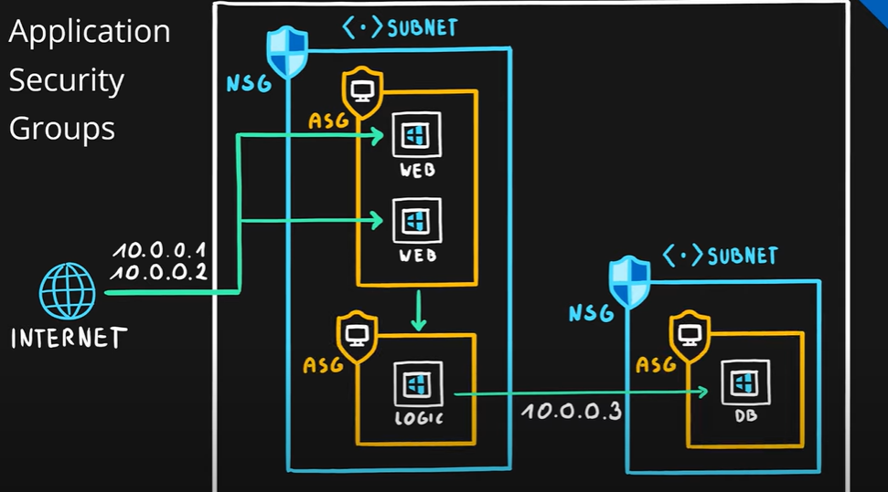

Instead of below we can see that we have grouped resources and then used ASG address to connect and control the traffic. **NSG controls the traffic while ASG is used to group the virtual machines and other resources.**

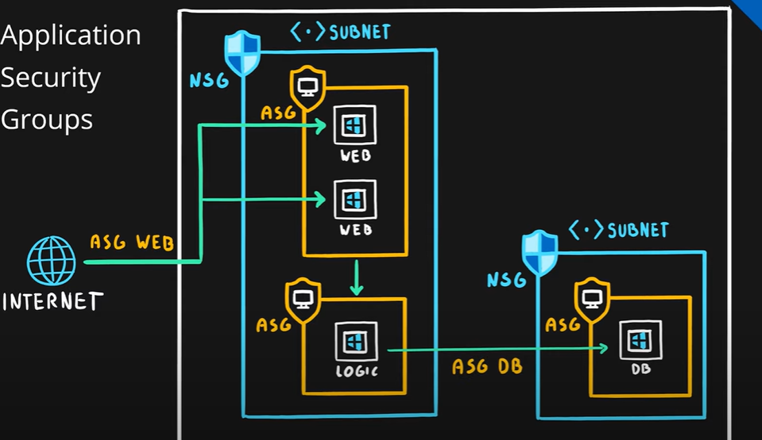

# Enterprise/Hybrid Networking Services

* **Azure Front Door**: Scalable and secure entry point for fast delivery of your global applications. It provides load balancing, application acceleration, SSL offloading, and application firewall capabilities at the edge locations closest to your users. It is a modern cloud CDN service that provides high performance, scalability, and security for web applications.
* **Azure Express Route**: A connection between your on-premise to Azure cloud from 50Mbps to 10Gbps.
* **Virtual WAN**: a networking service that brings many networking, security, and routing functionalities together to provide a single operational interface.
* **Azure Connection**: A VPN connection securely connects two Azure local network via IPsec.
* **Virtual Network Gateway**: A site-to-site VPN connection between an Azure virtual network and your local network. Azure VPN Gateway connects your on-premises networks to Azure through Site-to-Site VPNs in a similar way that you set up and connect to a remote branch office. The connectivity is secure and uses the industry-standard protocols Internet Protocol Security (IPsec) and Internet Key Exchange (IKE).

## VPN Gateway

* Azure VPN Gateway is a service that can be used to send encrypted traffic between Azure virtual network and on-premises locations over the public Internet. It can also be used to send encrypted traffic between Azure virtual networks over the Microsoft network.
* **Site to Site connections**: A cross-premises IPsec/IKE VPN tunnel connection between the VPN gateway and an on-premise VPN device.
* **Point to Site connection**: VPN over OpenVPN, IKEv2, or SSTP. This type of connection lets you connect to your virtual network from **a remote location**, such as from a conference or from home.
* **VNet to VNet**: An IPsec/IKE VPN tunnel connection between the VPN gateway and another Azure VPN gateway that uses VNet to VNet connection.
* Configure DirectAccess on a Windows Server 2012 server VM: While DirectAccess is a remote access technology, it's designed for providing seamless and always-on connectivity to on-premises resources for domain-joined devices. It's not the best fit for connecting remote workers to Azure VMs.
* Configure a Multi-Site VPN: Multi-Site VPN allows multiple on-premises sites to connect to the Azure virtual network, not individual remote users.

# Azure Traffic Manager

* **Azure Traffic Manager** operates at the DNS layer to quickly and efficiently direct incoming DNS requests based on the **routing method of your choice**.
* Routes traffic to servers that are geographically nearby to reduce latency.
* Fail-over to redundant systems in-case primary systems become unhealthy.
* Route to random VM to simulate A/B testing.

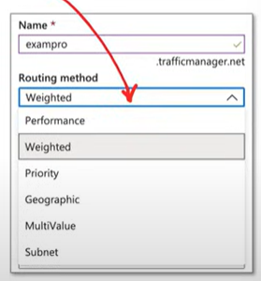 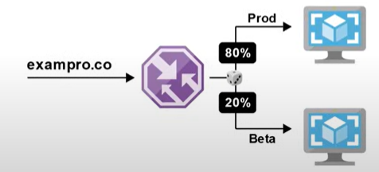

# IoT Services

* **IoT Central**: Connects your IoT devices to the cloud. It is a ready-made UX and API surface for connecting and managing devices at scale, delivering reliable data for business insights. It preassembles platform as a service offering, bringing together each service beneath it for an easy to configure, comprehensive, and secure IoT offering. **It is SaaS.**
* **IoT Hub**: Enable highly secure and reliable communication between your IoT application and the devices it manages. It provides a cloud-hosted solution back end to connect virtually any device. It is PaaS.
* **IoT Edge**: A fully managed service built on Azure IoT Hub. It allows data processing and analysis near the IoT devices. Edge computing is when you offload compute from the cloud to local computing hardware such as IoT devices, phones or home computers. Cloud intelligence deployed locally on IoT edge devices.
* **Azure Sphere**: Azure Sphere is a secured, high-level application platform with built-in communication and security features for internet-connected devices. It comprises a secured, connected, crossover microcontroller unit (MCU), a custom high-level Linux-based operating system (OS), and a cloud-based security service that provides continuous, renewable security.
* **Windows 10 IOT Core Services**: A cloud services subscription that provides the essential services needed to commercialize a device on Windows 10 IoT Core. Long term OS support and services to manage device updates and assess device health.

# Big Data and Analytics Services

* **Azure Synapse Analytics** (formally known as SQL Data Warehouse): Enterprise **data warehousing and big data analytics**. Intended to run SQL queries against large databases for things such as reporting. It is an integrated analytics service that combines big data and data warehousing. It allows you to ingest, prepare, manage, and serve data for immediate business intelligence and machine learning needs.
* **HDInsight:** HD is short for Hadoop. Run **open-source analytics software** such as **Hadoop, Kafka and Spark**.It makes it easier to process massive amounts of data using popular open-source frameworkds such as Hadoop, Spark, Hive, LLAP, etc.
* **Azure Databricks:** An Apache Spark-based analytics platform optimized for the Microsoft Azure cloud services platform. Third-Party Databricks cloud services supported within Azure.
* **Data Lake Analytics:** An on-demand analytics job service that simplifies big data. A data lake is storage repository that holds a vast amount of raw data in its native format until it is needed. It is an on-demand analytics job service that allows you to write queries to transform your data and extract valuable insights without needing to manage infrastructure.

# AI/ML Services

* AI: machines that perform jobs that mimic human behaviour
* ML: Machines that get better at a task without explicit programming.
* DL: machines that have an artificial neural network inspired by the human brain to solve complex problems.
* **Azure Machine Learning Service**: A service that simplifies running AI/ML related workloads allowing you to build flexible pipelines to automate workflow, Use python and R. Run DL workloads on technologies such as Tensorflow. It an enterprise grade service for the end-to-end machine learning lifecycle.
* Designer is a simple and powerful user interface that allows users to build their pipelines and train models with a drag and drop experience.
* Azure Machine learning workspace is a name for a top-level resource in Azure. It consolidates all the features of Azure machine learning service from a management perspective.
* **Azure Machine Learning Studio (classic)**: An older service that manages AI/ML workloads. Does not have a pipeline and other limitations. Workloads are not easily transferable from classic to the new service. It allows customers to manage machine learning workspace using a single and concise web portal interface.

## AI Services

* **Personalizer**: Delivers rich, personalized experience for every user.
* **Translator**: Add real-time, multi-language text translation to your apps, website and tools.
* **Anomaly detector**: Detect anomalies in data to quickly identify and troubleshoot issues.
* **Azure Bot Service**: Intelligent, serverless bot service that scales on demand.
* **Form Recogniser**: Automate the extraction of text, key/value pairs and tables from your documents.
* **Computer Vision**: Easily customise computer vision models for your unique use case.
* **Language Understanding**: Build natural language understanding into apps, bots and IoT devices.
* **QnA Maker**: Create a conversational question and answer bot from your existing content.
* **Text Analytics**: Extract information such as sentiment, key phrases, named entities and language from your text.
* **Content moderator**: Moderate text and images to provide a safer, more positive user experience.
* **Face**: Detect and identify people and emotion in images.
* **In Recogniser**: Recognise digital ink content, such as handwriting, shapes and document layout.

### Azure Cognitive Services.

* Azure Cognitive Services are APIs, SDKs, and services available to help developers build intelligent applications without having direct AI or data science skills or knowledge.
* Azure Cognitive Services enable developers to easily add cognitive features into their applications. The goal of Azure Cognitive Services is to help developers create applications that can see, hear, speak, understand, and even begin to reason.
* The catalog of services within Azure Cognitive Services can be categorized into five main pillars - Vision, Speech, Language, Web Search, and Decision.

# Serverless Services

* Serverless means that the underlying server, infrastructure and OS is taken care of by the Cloud Service Provider. It will generally be highly available, scalable and cost-effective.
* **Event-Driven Scale**: A serverless function can be triggered or trigger other events allowing you to compose complex applications and it just scales.
* **Abstraction of Servers**: Servers are abstracted away. Your code is described as functions. These functions can be running on different compute instances.
* **Micro-Billing**: Serverless compute could run for a fraction of a second. Billing into micro-second will save you money.

## Services

* **Azure** **Functions**: Run small amounts of code known as serverless functions in your favourite language: Python, C#, Java, JavaScript and PowerShell
* **Blob Storage**: Serverless Object Storage. Just upload files, don’t think about the underlying file-systems, resizing.
* **Logic Apps**: Allows you to build serverless workflows composed of Azure Functions. Building a state machine for serverless compute.
* **Event Grid**: Uses Pub/Sub messaging system to allow you react to events and **trigger** other Azure cloud services such as Azure Functions.

# Pricing and Support

## SLAs

* Service Level Agreement (SLA) described Azure’s commitments for **uptime** and **connectivity**. SLAs are individualized per Azure service.
* Uptime and connectivity are described as **Performance Targets.** A Performance Target is represented as a percentage %.
  + 99% (two nines)
  + 99.9% (three nines)
  + 99.999% (five nines)
  + 99.9999999% (nine nines)
* Azure does not provide SLAs for Free Tier or the shared tiers.

## Service Credits

* A service credit is when customers get **a discount applied to their Azure bill**, **as a compensation for an under-performing Azure product or service** based on the SLA.

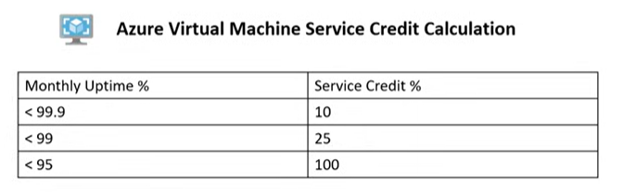

## Composite SLA

* Different services have different SLAs.
* A Composite SLA is when you combine SLAs across different service offerings.

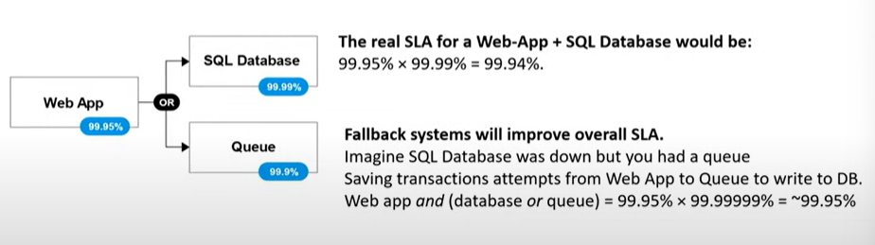

## TCO Calculator

* Estimate the cost savings you can realize by migrating your workloads to Azure.
* Generate out a detailed report and export as a PDF to send to decision makers.

## Azure Marketplace

* Azure Marketplace are apps and services made available by third-party publishers to quickly get started.
* The available apps and services can be Free, Free-Trial, Pay-As-You-Go, Bring-Your-Own-License.

## Azure Licensing

### Azure Hybrid Benefit

* Many customers have invested in Windows Server licenses and would like to repurpose this investment on Azure.
* The Azure Hybrid Benefit allows you to use your on-premises Windows Server and SQL Server licenses with **Software Assurance** to save on Azure Virtual Machines.
* Azure Hybrid Use Benefit (HUB): Give customers the right to use these licenses for virtual machines on Azure.
  + Windows Servers
  + SQL Servers
* HUB can be turned on and off at any time for existing VMs.
* HUB can be applied at deployment time for new VMs.

## Azure Subscriptions

* Azure Subscription is the same as saying our Azure Account.
* There are **4 tiers** of Azure Subscriptions.

1. Free Subscription
2. Pay-As-You-Go Subscription
3. Enterprise Agreement
4. Student Subscription

## Pricing Calculator

* Configure and estimate the costs of Azure products. No Sign-in require. Download an Excel spreadsheet and share with your boss.

## Azure Cost Management

* Perform cost-analysis, visualize the spending of your Azure cloud resources.
* Create budgets, set a budget threshold be alerted when approaching or exceeded.
* Azure Cost Management allows you to create and manage cost and usage budgets by monitoring resource demand trends, consumption rates, and cost patterns. It also allows you to use historical data to generate reports and forecast future usage and expenditures.

## Azure Reservations

* Azure Reservations offers discounted prices on certain Azure services. Azure Reservations can save you up to 72 percent compared to pay-as-you-go prices.
* To receive a discount, you can reserve services and resources by paying in advance.
* Spending limits can suspend a subscription when the spend limit is reached.
* Customers can purchase Azure Reservations for 1 and 3 years.

## Resource Tags

* A tag is a key and value pair that you can assign to azure resources.
* Tags for Resources are not inherited by default from their Resource Group. If you assign a tag to a resource group, all the Azure resources in that resource group are not assigned to the same tag.

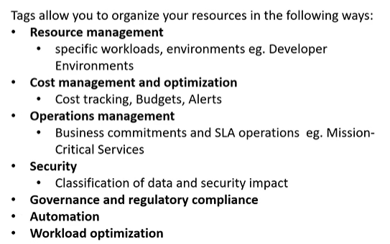

## Microsoft Purview Information Protection

* Microsoft Purview Information Protection (MPIP) is a collection of features within Microsoft Purview to help you discover, classify, and protect sensitive information wherever it lives or travels.

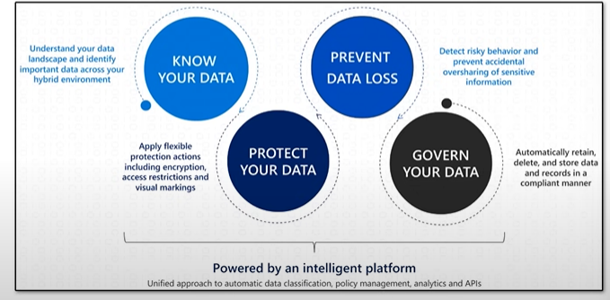

### MPIP – Know your data

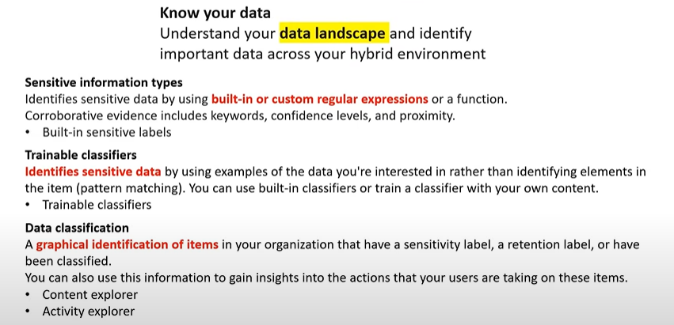

### MPIP – Protect your data

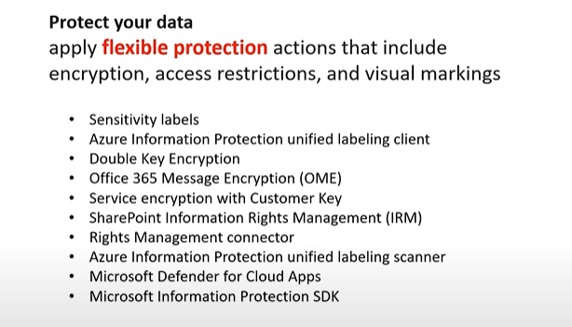

### MPIP - Prevent Data Loss

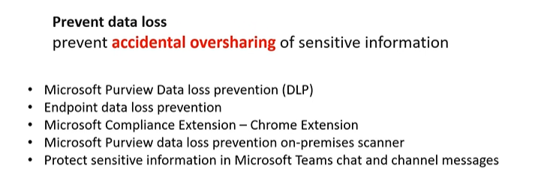

### MPIP – Govern your data

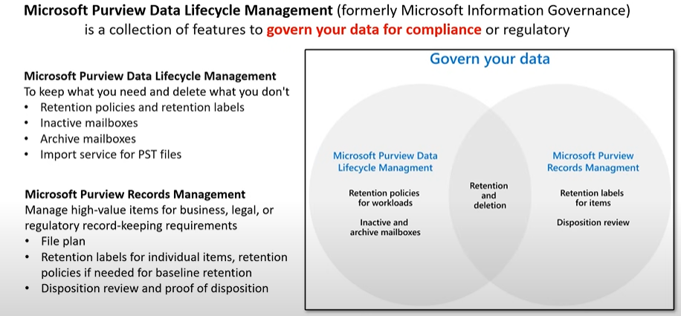

# Governance and Compliance

## Azure Policies

* Azure Policy enforce organizational standards and to assess compliance at scale.
* Policies do no restrict access; they only observe for compliance.
* Policy Definition: a policy definition is a JSON file used to describe business rules to control access to resources.
* Policy Assignment: The scope of a policy can effect. Assigned to a user, a resource group or management group.
* Policy parameters: values you can pass into your policy definition so your policies are more flexible for re-use
* Initiative definition: an initiative definition is a collection of policy definitions that you can assign eg a group of policies to enforce PCI-DSS compliance.

## Resource Locks

* As an admin, you may need to lock a subscription, resource group or resource to prevent other users from accidentally deleting or modifying critical resources.
* In the Azure Portal you can set the following lock levels
  + CanNotDelete(Delete): authorized users can still read and modify a resources, but they can’t delete the resource.
  + ReadOnly: authorized users can read a resource, but they can’t delete or update the resource.

## Azure Blueprints

* Azure Blueprints enable quick creation of governed subscriptions. Azure Blueprints is a service in Microsoft Azure that enables cloud architects and IT administrators to define a repeatable set of Azure resources that implement and adhere to an organization's standards, patterns, and requirements.
* Azure Blueprints help ensure consistency and compliance across multiple environments, allowing teams to deploy and manage Azure environments efficiently and securely.
* Compose artifacts based on common or organization-based patterns into re-usable blueprints.
* The service is designed to help with environment setup.
* Blue prints are a declarative way to orchestrate the deployment of various resource templates and other artifacts such as:
  + Role Assignments
  + Policy Assignments
  + Azure Resource Manager templates (ARM templates)
  + Resource Groups
* The Azure blueprints services is backed by the globally distributed Azure Cosmos DB. Blueprint objects are replicated to multiple Azure regions.
* ARM templates vs Azure Blueprints: Nearly everything that you want to include for deployment in Azure blueprints can be accomplished with an ARM template.
* ARM templates are stored either locally or in source control.
* Theres no active connection or relationship to the ARM template.
* Whereas there is relationship between blueprint definition (what should be deployed) and the blueprint assignment (what was deployed).
* It can also upgrade several subscriptions at once that are governed by the same blueprint.
* Azure blueprints supports improved tracking and auditing of deployments.
* Azure Blueprints enable you to define a repeatable set of Azure resources and policies that implement and adhere to your organizational standards, patterns, and requirements. It builds on top of ARM Templates and adds governance capabilities.

### ARM templates vs Azure Blueprints Comparison

* **Scope**: ARM Templates focus on deploying individual resources or a set of resources, whereas Azure Blueprints provide a more comprehensive solution that includes governance, policies, and entire environments.
* **Governance**: Azure Blueprints extend the capabilities of ARM Templates by including policy and access control configurations, making it easier to enforce organizational standards.
* **Ease of Use**: ARM Templates require knowledge of JSON and Azure's resource structure. Blueprints provide a higher-level abstraction, which can simplify managing complex environments.
* **Flexibility**: ARM Templates offer more granular control over resource deployment, while Blueprints focus on repeatability and governance across multiple deployments.

## Azure Portal

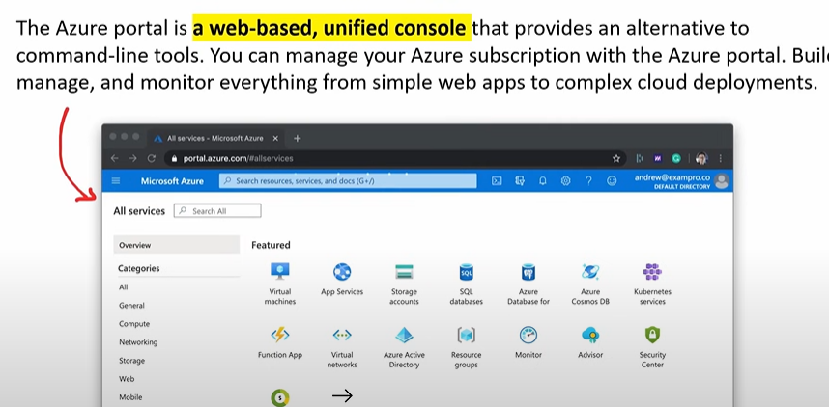

## Azure Preview Portal

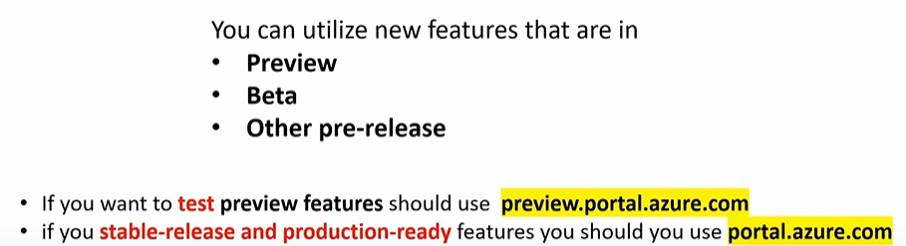

### Private Preview

The Private Preview phase is the initial testing and development phase where a limited number of participants are given access to a new feature or service. This is often by invitation only and is used to gather feedback from a select group of users who test the functionality in a controlled environment. The participants are usually under a Non-Disclosure Agreement (NDA) and are expected to provide detailed feedback and report issues.

For example, a new security feature in Microsoft 365 might be released to a small group of large enterprise customers to gather initial feedback before making it more widely available.

### Public Preview

Following the Private Preview, the Public Preview phase opens the testing to a broader audience. While still not the final version, the service or feature is now sufficiently stable for use in non-production environments or for testing in production with the understanding that it’s not fully supported. Public Preview is a critical step in the development process because it allows Microsoft to collect feedback from a wide range of users and environments, thus identifying any additional issues before the full release.

An example of a Public Preview might be the introduction of a new collaboration tool within Microsoft Teams, where any Microsoft 365 customer can enable and try out the new feature and provide feedback, but with the understanding that there may still be bugs, and the feature set may not be complete.

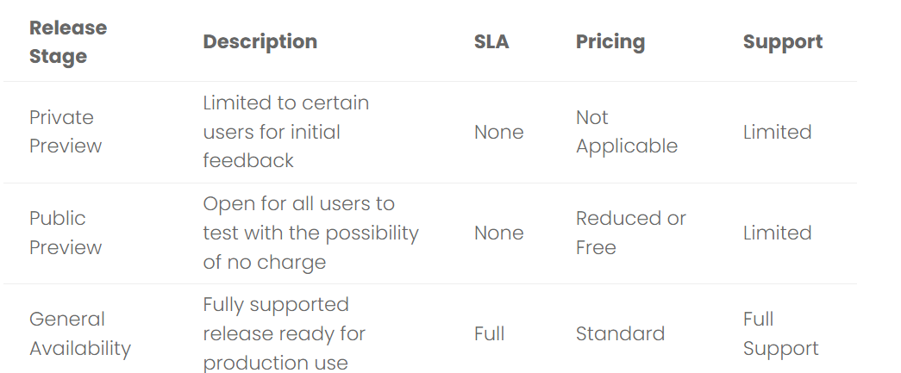

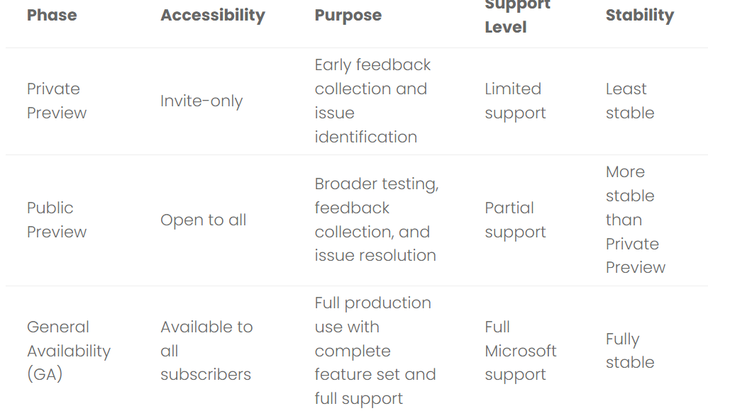

# Azure Management Tools

## Cloud Shell

* Azure Cloud Shell is an interactive, authenticated browser-accessible shell for managing Azure resources.
* It provides the flexibility of choosing the shell experience that best suits the way you work, wither Bash or PowerShell.

## Azure PowerShell

* PowerShell is a task automation and configuration management framework. A command line shell and a scripting language.
* Unlike most shells, which accept and return text, PowerShell is built on top of the .NET Common Language Runtime (CLR), and accepts and returns .NET objects.
* Azure PowerShell: a set of cmdlets for managing Azure resources directly from the PowerShell command line.

## Azure CLI

* CLI: A Command Line Interface (CLI) processes commands to a computer program in the form of lines of text. Operating systems implement a command-line interface in a shell or terminal.
* The Azure CLI can be installed on Windows, Mac and Linux. Once installed you can type az followed by other commands to create update delete view and manage Azure resources.

## Visual Studio Code

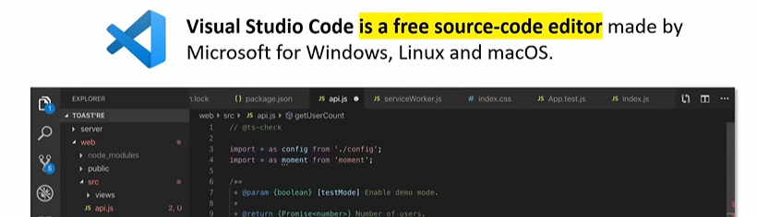

# Azure Resource Manager

* ARM is a service that allows you to manage Azure resources.
* ARM is a collection of services in the Azure Portal, so you cant simply type in “Azure Resource Manager”.
* It is a management layer that allows you to:
  + Create, update, delete resources.
  + Apply management features eg access controls, locks, tags
  + Writing infrastructure as code (IaC) via JSON templates
* The specific feature we are going to look at that make up ARM layer are the following:
  + Subscriptions
  + Management groups
  + Resource groups
  + Resource providers
  + Resource locks
  + Azure blueprints
  + Resource tags
  + Access control
  + Role-based access controls
  + Azure policies
  + ARM templates

## Use Case

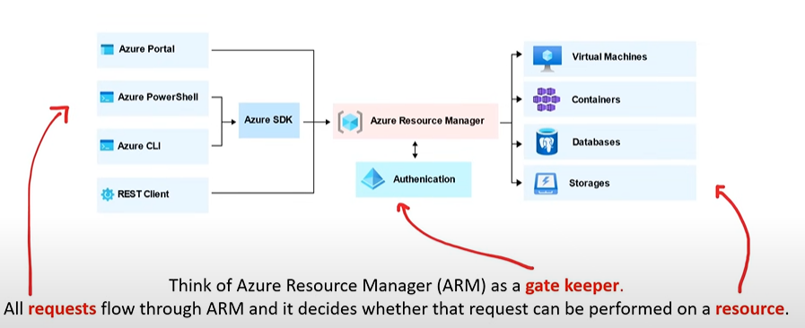

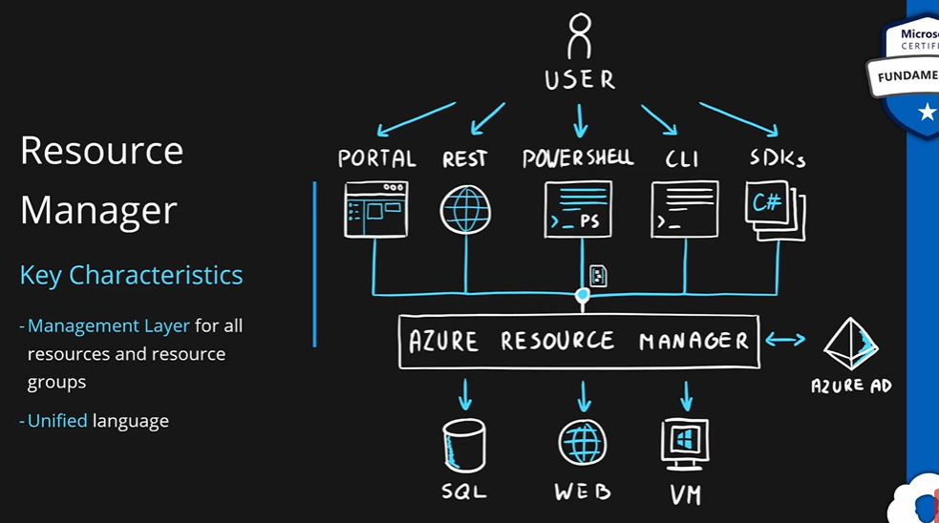

## Scoping

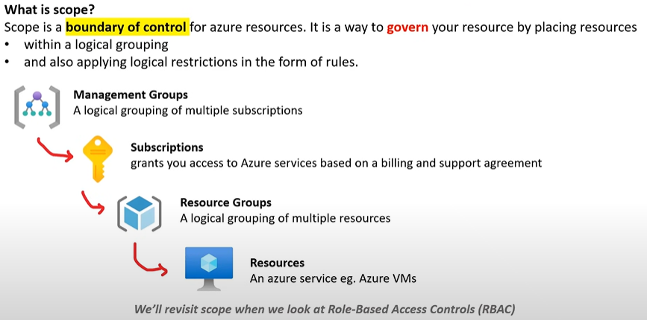

## ARM Templates

* Infrastructure as Code is the process of managing and provisioning computer data centers e.g. Azure through machine readable definition files e.g. JSON files rather than physical hardware configuration or interactive configuration tools.
* You write a script that will setup cloud services for you.
* IaCs can either be:
  + Declarative – You defined exactly what you want, and you get exactly that
  + Imperative - You define what you generally want, and the service will guess what you want
* ARM templates are JSON files that define azure resources you want to provision and azure services you want to configure.
* With ARM templates you can:
  + ARM templates are declarative.
  + Stand up, tear down or share entire architectures in minutes
  + Reduce configuration mistakes
  + Know exactly what you have defined for a stack to establish an architecture baseline for compliance
  + Modularity: Break up your architecture in multiple files and reuse them
  + Extensibility: Add PowerShell and Bash scripts to your templates
  + Testing: You can use the ARM template tool kit (arm-ttk)
  + Preview changes: Before you create infrastructure via template, see what it will create
  + Built In Validation: Will only deploy your template if it passes
  + Tracked Deployments: Keep track of changes to architecture over time
  + Policy as Code: Apply Azure policies to ensure you remain compliant
  + Microsoft Blueprints: establishes relationship between resource and the template
  + CI/CD Integration
  + Exportable Code: exporting the current state of a resource groups and resources
  + Authoring Tools: Visual Studio Code has advanced features for authoring ARM templates.

# Azure Monitor

* Azure Monitor is a comprehensive solution for collecting, analysing, and acting on telemetry from your cloud and on-prem environments.
* It can be used to create visual dashboards, smart alerts, automated actions, log monitoring.
* Many Azure services by default are already sending telemetry data to Azure Monitor.
* Azure Monitor is a platform that collects metric and logging data, such as CPU percentages. The data can be used to trigger autoscaling.

# The Pillars of Observability

* Observability is the ability to measure and understand how internal systems work in order to answer questions regarding performance, tolerance, security and faults with a system /application.
* To obtain observability you need to use Metrix, Logs and Traces. You have to use them together, using them in isolate does not gain you observability.
* Metrics: A number that is measured over period of time e.g. If we measured the CPU usage and aggregated it over a period of time we could have an average CPU metric.
* Logs: A text file where each line contains event data about what happened at a certain time.
* Traces: A history of request that travels through multiple Apps/Services so we can pinpoint performance or failure.

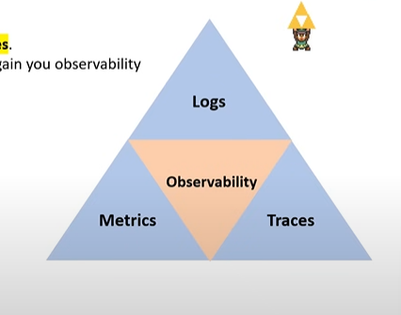

# Anatomy of Azure Monitor

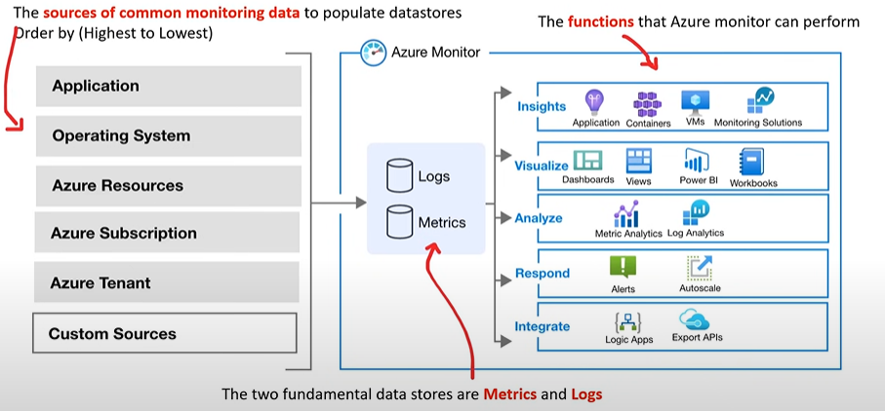

# Log Analytics

* Log Analytics is a tool in the Azure portal used to edit and run log queries with data in Azure monitor logs.
* Log analytics uses a query language called KQL.

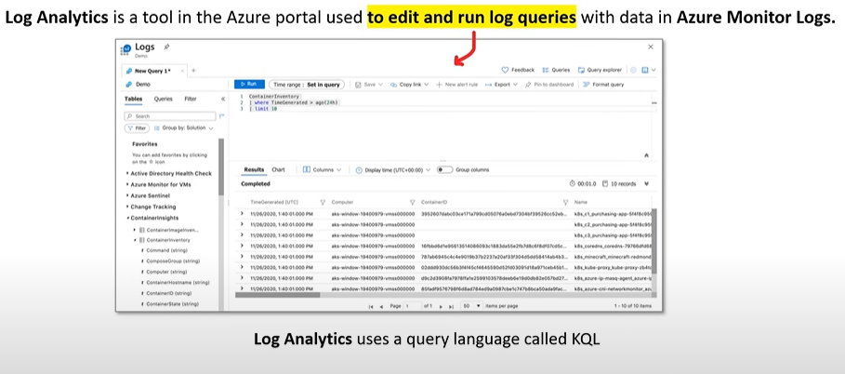

## Workspaces

* Log Analytics workspace is a unique environment for Azure Monitor log data. Each workspace has its own data repository and configuration, and data sources and solutions are configured to store their data in a particular workspace.

# Application Insights

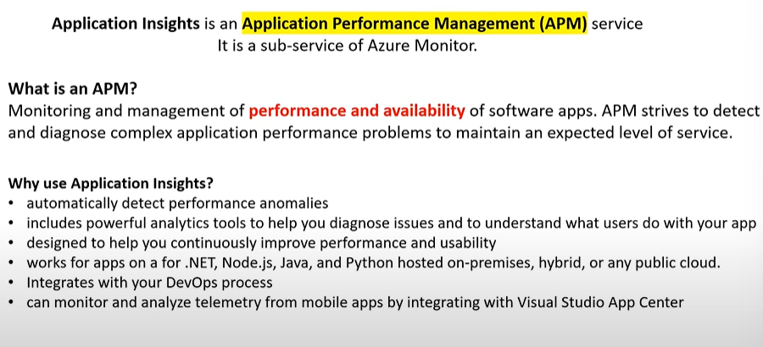

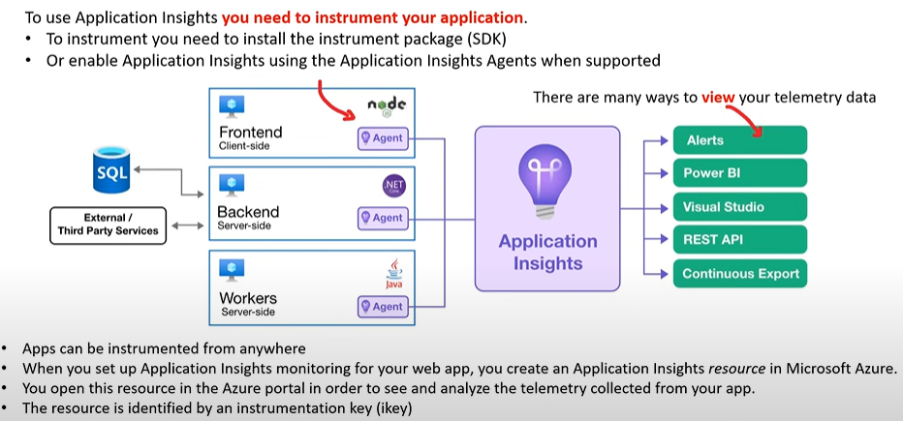

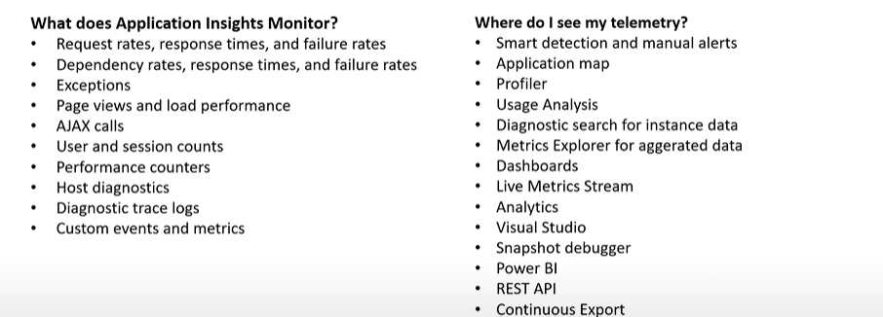

# Azure Alerts

* Alerts notify you when issues are found with your infrastructure or application. They allow you to identify and address issues before the users of your system notice them.
* Azure has 3 kinds of alerts: Metric Alerts, Log Alerts, Activity Log Alerts.
* When an alert is triggered you can be notified and have it take action.

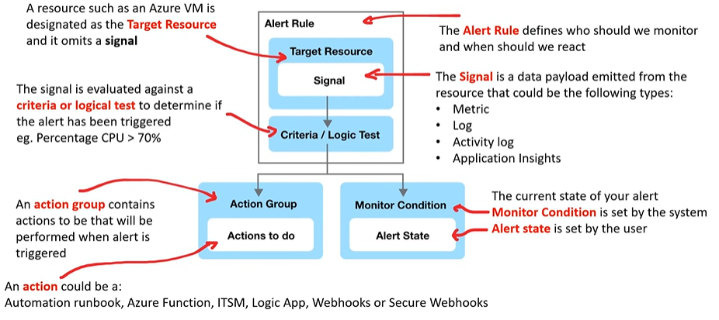

# Resources

## YouTube Links

* FreeCodeCamp: <https://youtu.be/5abffC-K40c?feature=shared>
* Adam Marczak - Azure for Everyone: https://youtube.com/playlist?list=PLGjZwEtPN7j-Q59JYso3L4_yoCjj2syrM&feature=shared

## Online Assessment

* https://www.examprepper.co/